After reading your article lists several Pro’s and several Con’s for using selective breading with dairy cows to produce high quality milk producing cows.

Pro’s | Con’s

How is selective breeding of dairy cows affected by technology?
Evidence: | Reasoning:
Artifical Selection Research Texts
Text #1
Source: Adapted from Successful Farming from agriculture.com

Genetic Testing Is Changing Cattle of All Stripes

The dairy industry, particularly the Holstein breed, has been on a DNA quest for more than 10 years, ever since better and cheaper genetic evaluation techniques became available, according to Tom Lawlor, a genomics expert for Holstein USA. Genetic evaluation refers to rating specific cows based on the presence or lack of specific genotypes that will result in desirable phenotypes or physical traits such as larger udders for milk production, fat content of the milk, overall health of the cow and potential reproductive success. According to Lawlor, “It is having a huge impact on dairy.”

Here are seven of the changes to dairy farming as a result of recent technology:
- Many dairy farmers now genetically test all of their offspring to obtain information about their genotypes called their “genetic potential”.
- The use of artificial insemination has increased the number of embryos a female with a high genetic profile can produce. These embryos can be harvested and implanted in other females with lower genetic potential, so that they are reproducing more elite offspring in a shorter amount of time.
- Many commercial dairy farmers who have cows with high genetic profiles now consider their dairy business as a selective reproduction business in addition to the profits of their milk sales. They are selling high genetically-profiled sperm or embryos to other farmers, helping those farmers increase their profits as well.
- It is not necessarily one breakthrough that is causing large gains in dairy productivity. It is a combination of technologies including genetic testing and artificial insemination.
- Genetic technology is still evolving, and accuracy of DNA tests continues to improve. “More and more breeders will utilize this technology by breeding specific cattle genotypes for specific environments and by producing more specialized genetics for different markets,” Lawlor says.
- Productivity of dairy herds is growing two to four times faster as a result of genomics testing. Lawlor compares two good New York state dairy herds. One is using advanced genomics testing, embryo transfer and other technologies to maximize genetic gains. The other is using older bulls and little genomic testing. After 10 years, the progressive herd makes over $1,000 more in lifetime profit per cow.
“It’s a matter of competition,” Lawlor says. “If you’re to remain in an industry, you have to keep up genetically with your neighbors, as well as other competitors farther away.”
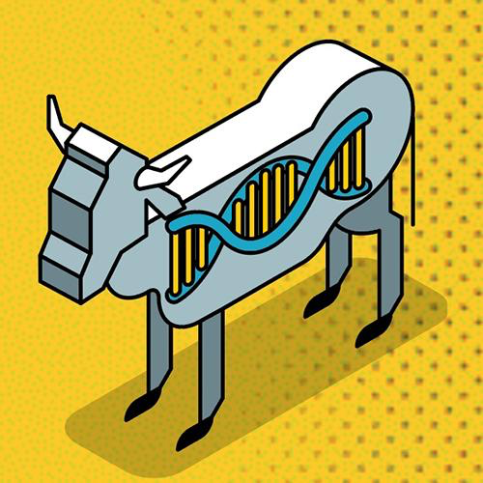

Vocabulary
Artificial insemination-fertilization of eggs using technology to introduce the sperm into the female with the intention of producing embryos.

Genomics-technology that involves the study and use of genes
Text #2
Source: VandeHaar, et. al. Journal of Dairy Science 2016

Harnessing the Genetics of the Modern Dairy Cow to Continue Improvements in Feed Efficiency

Feed efficiency (cost of feed intake vs. profit from the cow), has more than doubled for the US dairy industry in the past 100 years. This increase was the result of increased milk production per cow achieved through genetic selection and management of nutrition and care of the animals with the desired goal being greater profitability. With increased milk production per cow, more feed is consumed per cow, but a greater portion of the feed is used toward production of milk instead of regular maintenance and body growth. This profitable ratio will not always be the case as the improving milk production will reach maximum level that still creates profits for farmers.
Instead, we must also focus on new ways to enhance efficiency. One way to examine differences in efficiency among animals is residual feed intake (RFI). Cows that convert feed gross energy to net energy (energy in vs. energy out) more efficiently or have lower maintenance requirements than expected based on body weight use less feed than expected and thus have negative “RFI’s”. Cows with a low RFI likely digest and metabolize nutrients more efficiently and should have an overall profitability if they are also healthy, fertile, and produce high quantities of milk.
Genetic technologies will help to identify the ideal animals for artificial selection programs. Nutrition and management will also continue to play a major role in farm-level feed efficiency. Management practices such as grouping cows according to their predicted nutritional needs has also decreased our attention to individual cow needs. Accurate nutritional grouping is key to helping each cow reach its genetic potential. Perhaps new computer-driven technologies, combined with the use of genetic information, will enable us to optimize management for each individual cow within a herd, or to optimize animal selection to match management environments. In the future, availability of feed resources may change as competition for good land to raise the cattle increases. New approaches combining genetic, nutrition, and other management practices will help optimize feed efficiency, profitability, and environmental sustainability.

Example of expected results from breeding cows for more milk vs. less feed needed
Selective breeding for | Weight at maturity | Milk production | Lifetime income per cow | Lifetime feed cost per cow | Profit per cow
Current cows | 800 kg | 13.070 kg/yr | $15,330 | $6850 | $8480
Increased milk production | 800 kg | 14,530 kg/yr | $16,970 | $7280 | $9690
decreased size/less feed | 680 kg | 13,070 kg/yr | $15,240 | $6470 | $8770

Text #3

Source: Adapted from International Milk Genomics Consortium, 2014 milkgenomics.org

The Ups and Downs of Genetic Selection in Dairy Cattle

By Peter Williamson, Associate Professor of Physiology and Genomics, University of Sydney, Australia

- Fertility of dairy cows has been decreasing.
- Selective breeding has apparently contributed to this fall of fertility in some breeds.
- A missing region of DNA that is linked to fertility rates was identified in Nordic Red cattle.
- The unexpected higher prevalence of this mutation may be explained by its effect on increasing milk production.

Selective breeding of cows has resulted in enormous production gains and farming efficiencies in dairy industry. But what has been the impact of intensive selection on the modern dairy cow? Armed with recent advances in genomics, scientists are beginning to answer this question.
One of the most significant issues in dairy production in recent times is a falling rate of cow fertility (reproduction). Of course, this is a challenge for farmers, who must manage the pregnancy and lactation (milk producing) phases of their herds to maintain levels of milk production that will produce enough profit to keep their farms in business.
Physiologists and nutritionists studying this area have identified that an underlying cause is the competition for energy supply between what is required to establish a pregnancy and the demands of the udder during peak milk production. So, the more energy that goes into producing milk, the less energy is available to devote to becoming pregnant and maintaining a healthy fetus until birth. However, in Nordic Red dairy cattle, scientists from Denmark, Belgium, and Finland have now discovered another explanation. They have identified a section of the bovine (cow) genome that contributes both to higher levels of milk production and lower levels of fertility. So, farmers developing herds based on higher milk produced has meant that, as milk output has gone up, fertility has gone down in these breeds.
The combination of genetics and artificial insemination has brought substantial and widespread improvements in dairy production. A champion bull may contribute to hundreds, or even thousands, of daughters in dairy herds, nationally or sometimes internationally. This improvement in dairy production has been through several phases of development, and much of the gain in the past 25–30 years has been on the basis computerized systems that estimate the “value” of a bull based on the physical quality of his offspring. Recently, this approach has been complemented, or in some cases replaced, by the introduction of methods based on genomic selection (based on identified genes). Genomic selection uses DNA-based methods rather than simply physical traits (phenotypes) of the offspring, and has been made possible by the “bovine DNA sequencing project” and the associated development of powerful, low-cost genotyping technology. Whatever the system, these procedures have been developed to improve profits for farmers by making farming systems more efficient, so it is not surprising that selection of mating cows has been heavily weighted toward traits that deliver more milk, or milk with a particular quality, e.g. increased milk fat, or higher milk protein yield. What has been known by geneticists for many years is that certain traits overlap. There are regions in the genome that contribute to more than one outcome, and sometimes the outcome is a negative effect on the physical traits. They found that in some cows a missing piece of DNA (a mutation) accounted for low levels of fertility. To their surprise, they also found that, despite it contributing to low fertility rates, the missing piece of DNA was present in a lot of animals. Why would a mutation with negative effects not get weeded out of herds? The most likely explanation was that it was under forced selection, that is, it was providing benefits to humans and humans are making the breeding decisions. Further genetic analysis found this very same region was contributing to higher levels of milk production as was hypothesized.
As more cows with the mutation appeared in the herd, the overall production of milk may have increased, but overall fertility decreased.

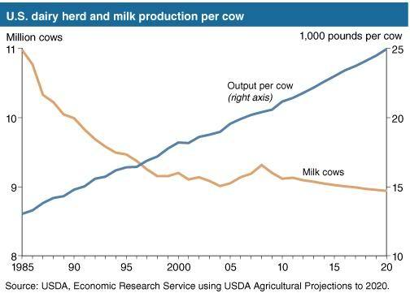

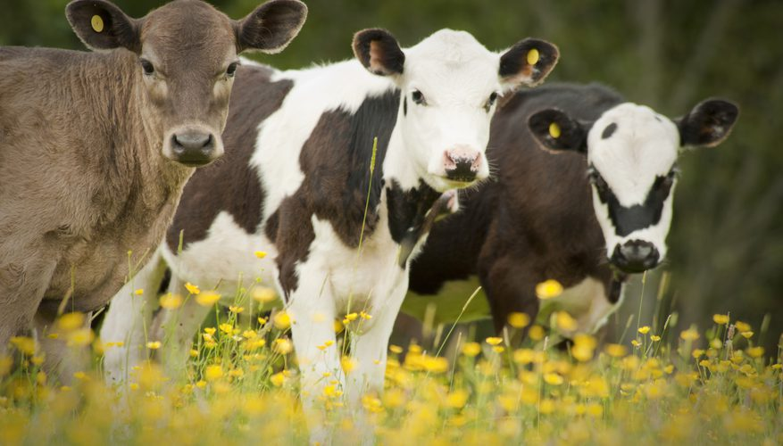
Text #4

Source: sciencing.com

Advantages & Disadvantages of Selective Breedings
Selective breeding is a modern agricultural technique used to genetically promote favorable characteristics in plants and animals. This is usually achieved through controlled breeding of high-yield plants and animals. The advantages of selective breeding include increased profitability and the ability to eliminate future offspring of diseases. The disadvantages include a loss of genetic variety and possible health difficulties and discomfort in the animals' lives.

Advantage: Higher Economic Profits
Selective breeding allows the promotion of characteristics more economically favorable to the farmer. For example, certain cows produce more milk on average than other cows. By breeding these cows with each other, the gene which results in high milk production will be passed on to the offspring.

Advantage: Eliminating Disease
Advances in genetic research have resulted not only in identification of high milk production but also in pre-screening and identification of certain genetic diseases. Controlled breeding of animals with no genetic diseases will eventually eliminate genetic diseases from future offspring.

Disadvantage: Loss of Variety

Selective breeding often requires inbreeding of animals and plants. This decreases genetic variety in the gene pool. As genetic variety is lost, the organisms express similar susceptibility to specific pathogens (disease-causing organisms). If a group of genetically similar animals or plants is attacked by a certain pathogen, there is a likelihood that the whole population will be vulnerable to the disease. Therefore, unless carefully monitored, selectively bred populations are constantly in danger of being wiped out by disease.
Disadvantage: Animal Discomfort
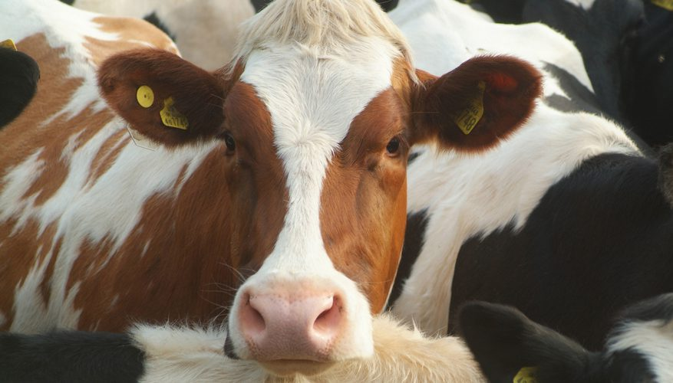
Breeders who want to encourage certain desirable traits, may unintentionally reproduce traits harmful to the animal's health. For example, for economic benefit, farmers may breed cows with large udders to increase their offspring's milk yield. These large udders may be too heavy for the cow to bear and cause great discomfort. The larger the udders, the more milk that is produced, but where is the line drawn for productivity vs. discomfort to the animal.

