Echo Lab Instructions-k Name: ________________________________________ Date: ___________ Period: ______

An echo is a sound that bounces off a surface and returns to its starting point. You know you are hearing an echo when you make a sound and then hear it again a very short time later. You may have heard echos when you talk in a large empty room with no carpet on the floor. Some animals, such as bats and dolphins, make sounds and then analyze the echos to determine how far away things are.

Echos are especially impressive when they are heard in a natural setting. Four teams of students are investigating echos by bouncing brief sound pulses off a smooth cliff. Each team has a sound generator that emits a loud sound pulse of a single frequency, a computer that displays a graph of the sound, and a stopwatch. The students also have the map below that lets them know how far away they are from the cliff.

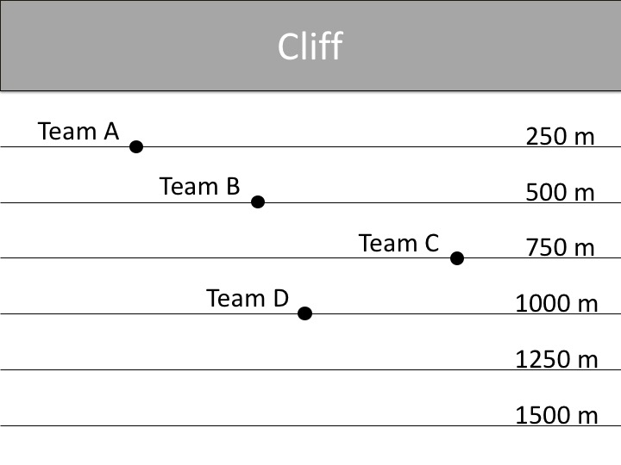

Your job is to analyze the echo data from TEAM A. You will then combine your data with the analysis of the other team data in order to develop a mathematical model that describes how speed, wavelength, and frequency are related.

Echo Data for Team A

Team A emits a pulse of 256 Hz from their sound generator. They hear an echo 1.46 seconds later. Their computer displays the following graph of their sound pulse.
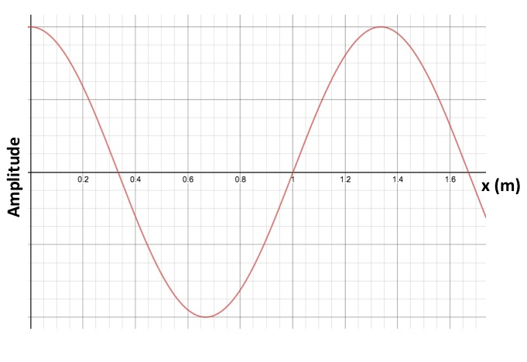

1. How far is the team from the cliff? ____________
2. How far does the sound travel to produce an echo? ____________ (Explain your answer.)

3. What is the speed of the sound? ____________ (Show your work below.)
Speed = Distance/Time

4. What is the frequency of the sound? ____________

5. What is the wavelength of the sound? ____________ (Explain your answer.)
Use the wave on the graph and measure from crest to crest.
Echo Data for Team B

Team B emits a pulse of 512 Hz from their sound generator. They hear an echo 2.92 seconds later. Their computer displays the following graph of their sound pulse.
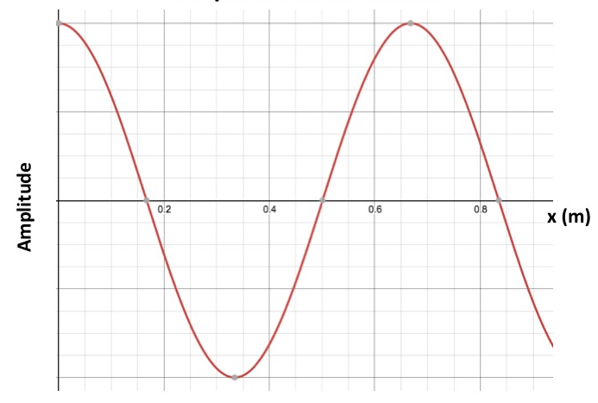
1. How far is the team from the cliff? ___500m_____
2. How far does the sound travel to produce an echo? ___1000m___ (Explain your answer.)
The sound will travel to the cliff wall and back (500+500=1000m)
3. What is the speed of the sound? __342.466_ (Show your work below.)
Speed = Distance/Time
1000m/2.92second=342.466 (round to the nearest thousandths or 3 places after the decimal)
4. What is the frequency of the sound? ____512Hz__

5. What is the wavelength of the sound? ____.67m___ (Explain your answer.)
Use the wave on the graph and measure from crest to crest.
Echo Data for Team C

Team C emits a pulse of 128 Hz from their sound generator. They hear an echo 4.39 seconds later. Their computer displays the following graph of their sound pulse.
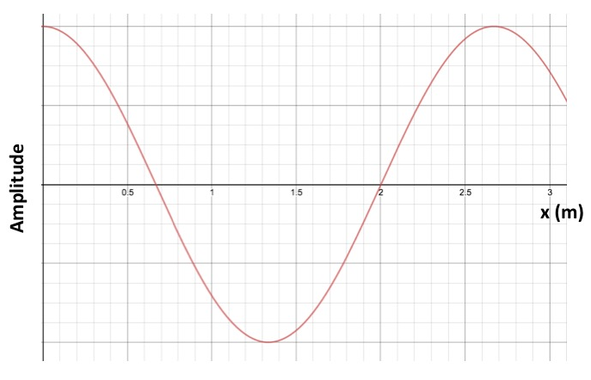
1. How far is the team from the cliff? __750M___
2. How far does the sound travel to produce an echo? __1500M___ (Explain your answer.)
The sound will travel to the cliff wall and back
3. What is the speed of the sound? __341.686____ (Show your work below.)
Speed = Distance/Time
1500m/4.39=341.686

4. What is the frequency of the sound? ___128Hz___

5. What is the wavelength of the sound? ___2.68__ (Explain your answer.)
Use the wave on the graph and measure from crest to crest.

Echo Data for Team D

Team C emits a pulse of 440 Hz from their sound generator. They hear an echo 5.85 seconds later. Their computer displays the following graph of their sound pulse.

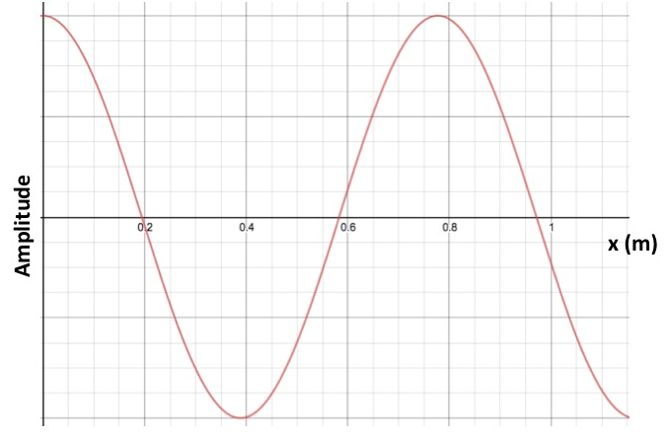
1. How far is the team from the cliff? __1000m___
2. How far does the sound travel to produce an echo? __2000m_(Explain your answer.)
The sound will travel to the cliff wall and back
3. What is the speed of the sound?___341.880__ (Show your work below.)
Speed = Distance/Time
2000m/5.85second=341.880
4. What is the frequency of the sound? 440Hz______

5. What is the wavelength of the sound? _.777m________ (Explain your answer.)
Use the wave on the graph and measure from crest to crest.

Developing the Mathematical Model

- Record the speed, frequency, and wavelength data for Team A below. The information for teams B,C, and D have been completed for you.
Team | Speed  v  (m/s) | Frequency  f  (Hz or 1/s) | Wavelength  $$λ$$  (m) | v =
A
B | 342.466m/s | 512Hz | .67m
C | 341.686m/s | 128Hz | 2.68m
D | 341.880m/s | 440Hz | .777m

- Compare the speed of sound in air for all Teams. What can you conclude about the speed of sound in the air, v?

- Construct an equation (v = ?) that relates the speed of sound, v, to its frequency, f, and wavelength, $λ.$ Test your equation using the data in the table, performing calculations on scratch paper or in the space below. Small numeric errors in your calculations are expected, but large errors mean your equation is not correct. If your equation does not produce good results, write and test another equation.

- Write your equation in the header of the right column. Fill in the rest of the column with the results from your equation yields.

- How close are your calculated values of speed in the right column to the values in the second column? How do you explain slight discrepancies in the values?

- A scientist determines that a 500 Hz sound wave has a wavelength of 3.06 meters when traveling through salt water. How does the speed of sound in water compare to the speed of sound in air? Show your work below.

