Electromagnetic Tasks Name: ___________________________________ Date: ______

Complete the tasks in the following order: Explore it, Watch it, Research it, Read it, Illustrate it – on the back.

Watch It!

1.

2.

3.

4.

Read It! #2

1. _______________ _________________
2. _______________ _________________

Read It! #1

1.____________________________________________

2. __________________________

3._______________________________________________________________________________________________________________________________________________

4.

Research It!

1.

2.

3.

4.

5.

Explore It!

1.

2.

3.

4.

5.

Assess It!

1._____ 2. _____

3.

4.

5. ______ ______

6.

**Research It!**

Directions:

1. Go to <https://education.jlab.org/qa/electromagnet_is.html>
2. Read “Electromagnets” and answer the following questions on your answer sheet.

Questions:

1. What can be changed with an electromagnet?
2. What happens when you reverse the flow of electricity in an electromagnet?
3. What happens when you loop the electrified coils of wire around an iron core?
4. What material is magnetic?
5. What happens when the electricity running to the electromagnet is turned off?

**Watch It!**

Directions:

1. Go to <https://www.youtube.com/watch?v=_ygmHnjNYNo>
2. Watch the video and answer the questions below.

Questions:

1. What is created by electricity running through a wire?

2. What is different about an electromagnet and a regular magnet?

3. What is one way to control the power of magnetism in an electromagnet?

4. What are two everyday devices that use electromagnets/electromagnetism?

**Explore It!**

Directions: [Click here](https://rcschools.zoom.us/rec/share/sn9a7668IeXv806-Hfd8wXzGkHFIvnKMSd6phwxZFUwJi4Wd0E97F_XzARA5o23k.nyr0WNAa25__IFLY?startTime=1601330757000) for the demo video

1. Place the compass near the wire (very close!!).
2. Turn the switch to the “on” position and OBSERVE
3. Move the compass around the wire and OBSERVE
4. Turn the switch to the “off” position

Questions:

1. What happened to the compass needle when the switch was on?
2. What happened inside the wire when the switch was on?
3. What changed with the compass as you moved it around the wire?
4. What do you think caused the changes in the compass needle?
5. What do you think formed around the outside of the wire?

**Read It! #1**

Directions:

1. You will need your textbook for this read it station. (pictures of the pages are included below)
2. Read page 66-67 and answer the questions below.

Pg 66 (below)

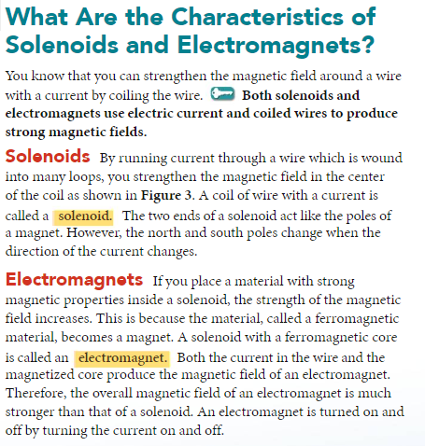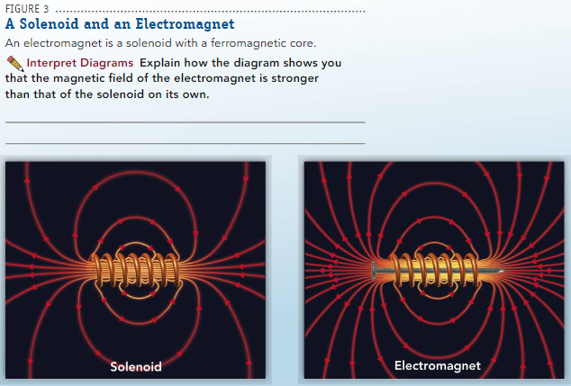

Pg 67 (below)

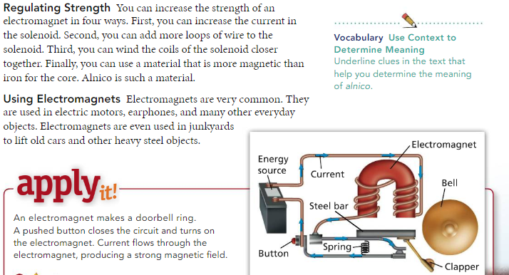

**Questions:**

1. The two ends of the solenoid act like the ____________ of a magnet.
2. What causes the magnetic field produced by an electromagnet to be much stronger than the magnetic field produced by a solenoid?
3. What are the four ways you can increase the strength of an electromagnet?
4. Use the pictures on page 66 (Figure 3). Sketch a solenoid and the magnetic field.

**Illustrate it!**

Directions:

1. Use the 3 pictures provided to help sketch an electromagnet.
2. Include the labels listed below on your drawing.

-Battery - Magnetic field

-Iron nail - North pole

-Solenoid - South pole

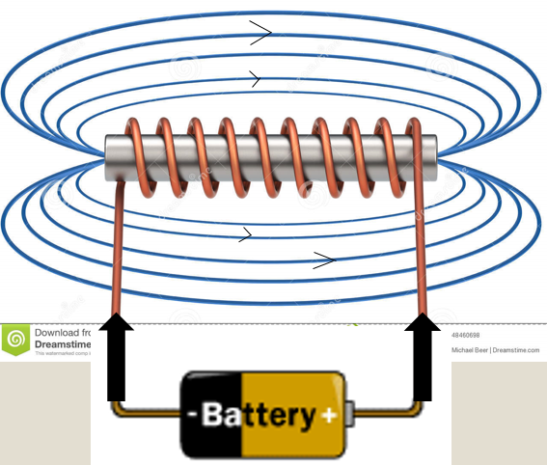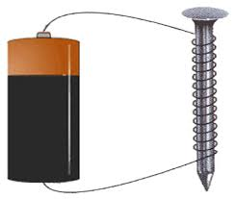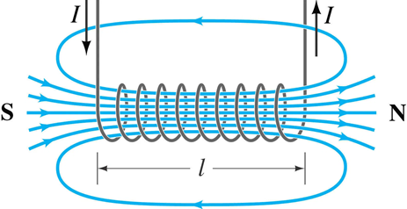

**Read it! #2**

Directions:

1. You will need your textbook for this read it station.
2. Turn to page 72. (pictures of the page is included below)
3. Read and answer the questions below.

Pg 72 (below)

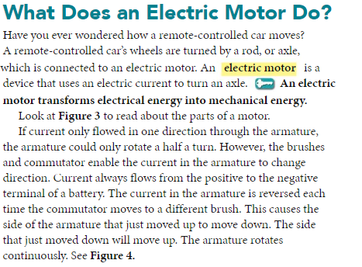

Questions:

1. An electric motor transforms electrical energy into ____________ ____________.
2. The electric current always flows from the ________ terminal to the ___________ terminal of the battery.
3. What causes the armature to continuously move up and down?

Assess it! (complete this task last)

1. A student made an electromagnet by wrapping copper wire around an iron nail. The student then connected each end of the electromagnet to the opposite terminals of a battery.

**The electromagnet will best function as a magnet as long as...?**

1. Electric current flows through the nail
2. Electrical energy is transformed into potential energy
3. Electric current flows through the wire
4. Electrical energy is induced within the wire
5. How could you modify this electromagnet so that it would be able to pick up the maximum amount of paper clips?

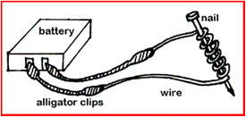

1. Move the ire core back and forth through the solenoid
2. Use a thicker wire
3. Reverse the connection to the battery
4. Increase the number of wire coils around the iron core
5. If you switch the connections to the power sources, the electricity in the electromagnet will flow in the opposite direction. What will happen to the magnetic field as a result?

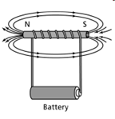

1. Explain why the magnetic field around the E-mag shown is incorrect.

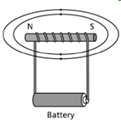

1. Which two answer choices correctly explains how an electromagnet and a bar magnet are similar?
2. Both E-mags and bar magnets have an iron core.
3. Both E-mags’ and bar magnets’ magnetic fields are strongest at the poles.
4. Both E-mags’ and bar magnets’ opposite poles repel each other
5. Both E-mags’ and bar magnets’ electrical charges flow north to south.
6. Both E-mags and bar magnets have the ability to turn on/off.
7. Both E-mags and bar magnets have the ability to be strengthened easily.
8. Explain why a compass needle would be attracted to a wire with flowing electricity?

