Electromagnetism Virtual Lab Name: ___________________________________ Date: _______________ Period: ____
Use the following link to complete the virtual lab: https://my.hrw.com/sh2/sh07_10/student/flash/virtual_investigations/hst/emg/hst_emg_vi.html
- After you listen to the introduction click “continue” to move to the next screen.
- Click on the word “slow” and then click the “push magnet” button. Once the magnet moves click “move magnet” again. Be sure to watch the needle move on the meter. You can repeat this process if needed.
Question: What is being produced as the magnet moves slowly through the coils? __________________________
Question: What is the purpose of the wire and magnet? _______________________________________________
- Click the word ‘medium” and then click “push magnet”. Once the magnet moves click “move magnet” again. Be sure to watch the needle move on the meter. You can repeat this process if needed.
Question: What is the galvanometer doing? _________________________________________________________
- Click the word “fast” and then click “push magnet”. Once the magnet moves click “move magnet” again. Be sure to watch the needle move on the meter. You can repeat this process if needed.
Question: Which speed produces the most electric current? _________________________________
Question: When the movement of the magnet is reverse, what happens to the electric current? (hint: watch the needle) __________________________________________________________________________________________________
Question: What is the process of creating electricity in this manner called? _____________________________________
- Click “continue” and answer the multiple choice question on the screen.
- Once you have read the instructions on the screen click “close”
- Click on the picture of 10 loops and then click “test”. Be sure to watch the galvanometer. You can repeat this process if needed.
- Click on the picture of 20 loops and then click “test”. Be sure to watch the galvanometer. You can repeat this process if needed.
- Click on the picture of 50 loops and then click “test”. Be sure to watch the galvanometer. You can repeat this process if needed.
Question: Which number of loops/coils generated the most electricity? ________________________
Question: In order to generate the most electricity what should be done with the number of loops/coils and the magnet?
______________________________________________________________
______________________________________________________________

- Click “continue” and answer the multiple choice question on the screen.
- Once you have read the instructions on the screen click “close” AND listen to the introduction.
- Click “continue” and then read the instructions. Once you have read the instructions click “close”
- Read each clue in the upper right hand side of the screen. Click on the picture of the required item in order to build your electric generator.
Question: In a generator what is the role of the permanent magnet? (hint: hover over the red permanent magnet) __________________________________________________________________________________________________
Question: In a generator, which device rotates inside the permanent magnet? __________________________________
Question: In a generator which item conducts the electric current to the rest of the circuit? __________________________________________________________________________________________________
Question: What are the four main parts of a simple electric generator which are necessary to induce electricity? ____________________________________________________________________________________________________________________________________________________________________________________________________
Question: In a generator which device measures the amount of the electric current? _____________________________
- Once you have assembled your generator click “turn handle”. Observe the light bulb and the meter. You may “replay” this process if necessary.
Question: In a generator, what happens when you rotate the crank handle? ____________________________________
Question: Why is the generator you just assembled called an alternating-current (AC) generator?
- The north and south poles of the magnet alternate as the coil turns in the magnet.
- The type of current alternates between AC and DC as the coil turns in the magnet.
- The direction of the current alternates as the coil turns in the magnet.
- The direction in which the coil is turning in the magnet alternates as the current is generated.
Question: Explain how to increase the amount of electricity being produced by your electric generator.
_________________________________________________________________________________________________
Question: Circle the picture of the process which is most effective at producing electricity. Then explain why it is more effective.
____________________________________________________________________________________________________________________________________________________________________________________________________
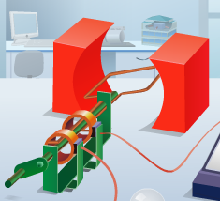
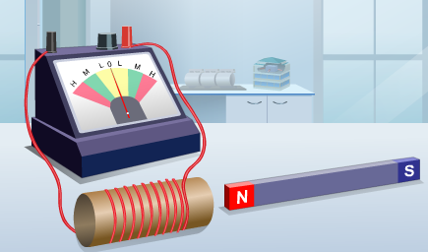

Picture #1 (Straight line induction) Picture #2 (Coil rotation induction)

