**EM Wave Stations** Name: _______________________________ Date: ______________

Complete the EM wave stations in the following order: Watch it, Read it, Explore it, Illustrate it, Assess it.

END

Explore It



Illustrate It!



Watch It!

1.__________________ ___________________

___________________ ___________________

___________________ ___________________

2. ______________________

3._______________________

4._______________________

Read It!

1.___________________________________

2.______________________________________________________________________________

3._________________ ___________________

4._____________________________________________________________________________

Assess It!

Do this station last!

1. _____
2. _____
3. _____
4. _____

**Watch It!**

1. Watch the following **video goo.gl/7w1x8Y (stop at 3:15)**
2. Answer the following:
   1. Name 4 household items that emit (give off) electromagnetic waves?
   2. Which types of waves have the shortest wavelength?
   3. Which types of waves have the longest wavelength?
   4. While watching your TV you are being bombarded with so many other waves. What type of wave are humans “tuned” to detect? (stop at 3:15)

Read It!

The Electromagnetic Spectrum

When you tune your radio, watch TV, send a text message, or pop popcorn in a microwave oven, you are using electromagnetic energy. You depend on this energy every hour of every day. Without it, the world you know could not exist.

Electromagnetic energy travels in waves and spans a broad spectrum from very long radio waves to very short gamma rays. The human eye can only detect only a small portion of this spectrum called visible light. A radio detects a different portion of the spectrum, and an x-ray machine detects yet another portion. NASA's scientific instruments use the full range of the electromagnetic spectrum to study the Earth, the solar system, and the universe beyond.

Our Sun is a source of energy across the full spectrum, and its electromagnetic radiation bombards our atmosphere constantly. However, the Earth's atmosphere protects us from exposure to a range of higher energy waves that can be harmful to life. Gamma rays, x-rays, and some ultraviolet waves are "ionizing," meaning these waves have such a high energy that they can knock electrons out of atoms. Exposure to these high-energy waves can alter atoms and molecules and cause damage to cells in organic matter. These changes to cells can sometimes be helpful, as when radiation is used to kill cancer cells, and other times not, as when we get sunburned. The electromagnetic spectrum describes all the wavelengths of light – both seen and unseen. The shorter the wavelength, the more energetic the light. By using telescopes sensitive to different wavelength ranges of the spectrum, astronomers get a glimpse into a wide variety of objects and phenomena in the universe.

**Questions:**

1. According to the passage the human eye can detect what kinds of waves?
2. What does the term ‘ionizing’ mean in  the 3rd paragraph?
3. Shorter wavelengths have ___________________ energy and longer wavelengths have __________________ energy.
4. Another title for this passage could be?

Explore It!

[Click here](https://drive.google.com/file/d/1GSZzQr7OazSalMN75C3MrQQYHSuAgzIQ/view) and watch the video for explore it.

Question: On your answer document, draw the waves as they move from the starting point to the ending point. Make note of how the waves change shape after they pass through the opening in the middle.

Illustrate It!

Read and study the Electromagnetic Spectrum diagram below. Then write the name of the waves in the correct box on your answer document. **(Hint- Use these names to fill in boxes 1-7: x-ray, gamma ray, visible light, microwave, radio, infrared, ultraviolet)**

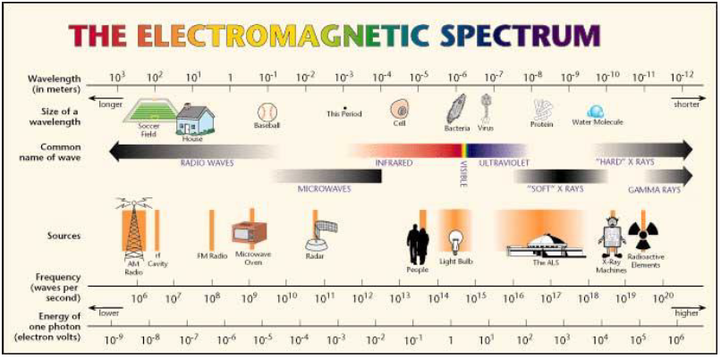

Assess It!

Answer these questions last, after you have completed all other tasks.

1. Which of the following devices is designed to produce electromagnetic radiation with the **longest** wavelength in order to operate?

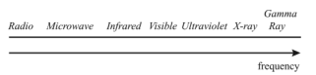

1. Light bulb b) Microwave oven c) X-ray microscope d) FM radio transmitter
2. From a comparison of the wave traces, which of the following correctly describes the relationship of sounds B to sound A. 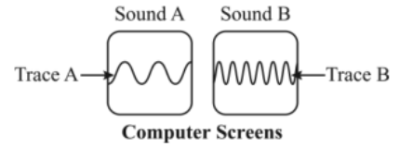
3. Sound B has a higher velocity. b) Sound D has a higher amplitude.
4. Sound B has a higher frequency. D) Sound B has a longer wavelength

Assess It! Continued

1. Which of the following statements describes another property of these waves?

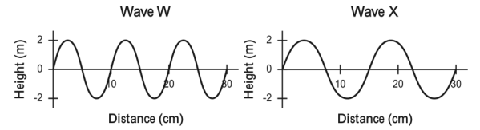

1. Wave W has a larger period than wave X. b)Wave W has a lower frequency than wave X.

c)Wave W has a greater amplitude than wave X. d) Wave W has a shorter wavelength than wave X.

#4 Astronauts in space would not be able to hear a landslide on the moon because

1. The lunar dust deadens sounds. B) Intensive sunlight destroys sound waves.

c)The magnetic field of the mood is too weak to carry sound.

d) There are no air molecules on the Moon to carry sound.

4. Which statement about the EM Spectrum is false?

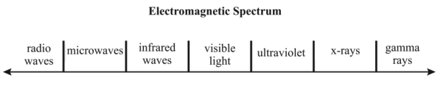

1. UV waves have more energy than x-rays
2. Gamma rays have the highest frequency
3. Microwaves have more energy than radio waves but less energy than infrared waves.
4. X-rays have more energy than every other EM wave except gamma rays.
5. Radio waves have the longest wavelengths.