4600 MYA
Earth is formed
#1
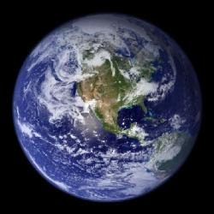
4530 MYA
The Moon is formed
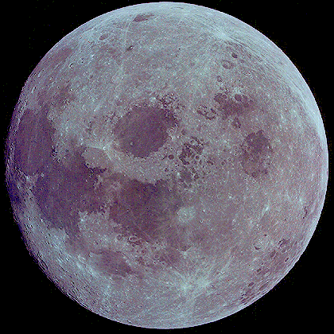
3800 MYA
Earth’s crust solidifies and oceans formed from condensation of atmospheric water
#2

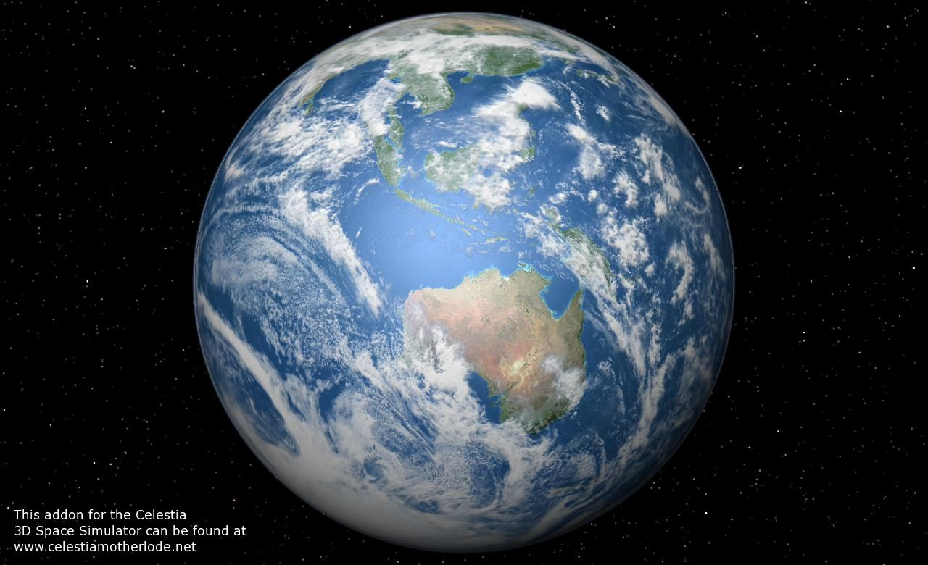
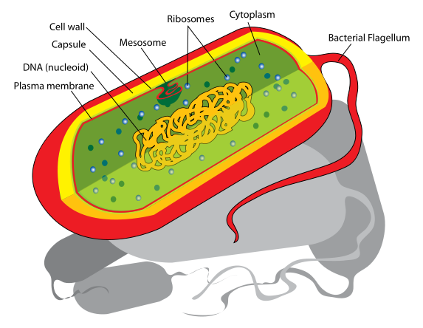
3500 – 2800 MYA
First Prokaryotic organisms
#3

2400 MYA
Oxygen levels in the atmosphere rise
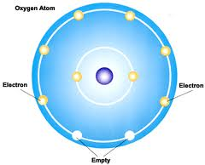
1500 MYA
#4
First Eukaryotic organisms
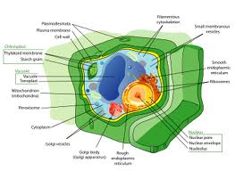
1500 – 600 MYA
Rise of Multicellular organisms
580 – 545 MYA
First Fossils
#5
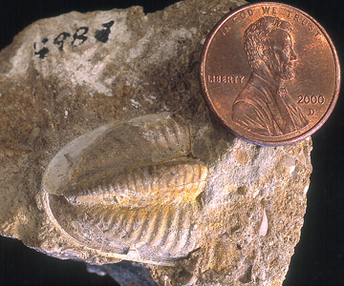
500 – 450 MYA
First Vertebrates – Fish
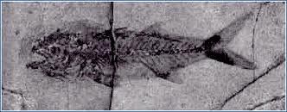
430 MYA
Waxy coated Algae begin to live on land
#6
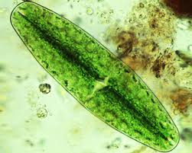
420 MYA
First Millipedes live on land
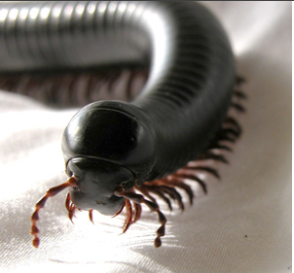
375 MYA
#7
Appearance of primitive sharks
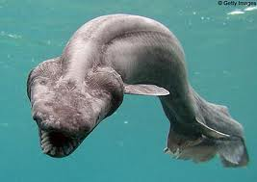
350-300 MYA
Rise of Amphibians
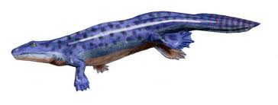

350 MYA
#8
Primitive Insects and Primitive Ferns (first plants with roots)
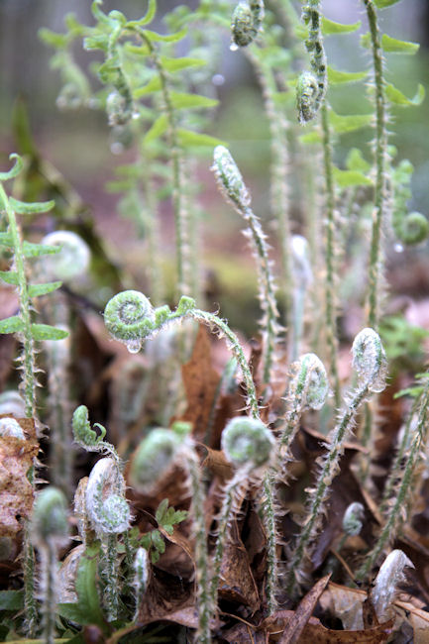

300 – 200 MYA
#9
Rise of Reptiles
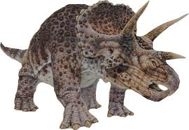
300 MYA
Winged Insects have evolved
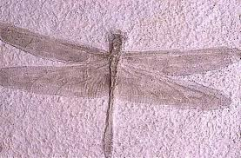
200 MYA
Pangea starts to break apart and the appearance of mammals
#10
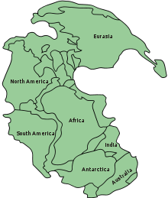

65 MYA
#11
Extinction of Dinosaurs and the beginning of the reign of mammals
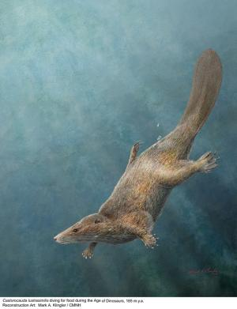

20-12 MYA
#12
Chimpanzee and hominid lines evolve
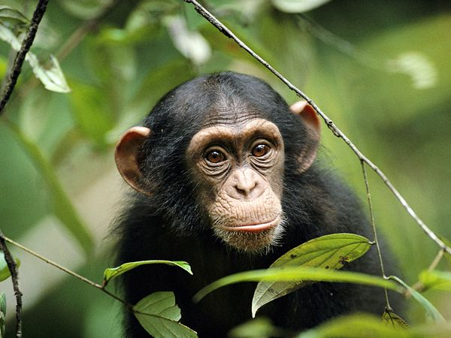
4 MYA
Development of hominid bipedalism
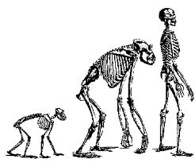
4 – 1 MYA
#13
Australopithecus exist
3.5 MYA
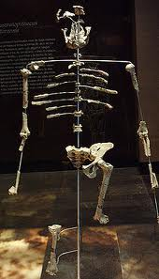
The Australopithecus Lucy walks the Earth

2 MYA
#14
Widespread use of tools

2 – 0.01 MYA
Most recent ice age

1.6 – 0.2 MYA
#15
Homo erectus exists
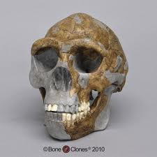
1 – 0.5 MYA
Homo erectus tames fire
0.2 - .03 MYA
#16
Homo sapiens neanderthalensis exist
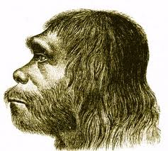

0.05 – 0 MYA
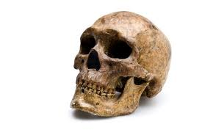
Homo sapiens sapiens exist

0.012 MYA
Homo sapiens sapiens domesticated dogs in Kirkuk, Iraq
#17
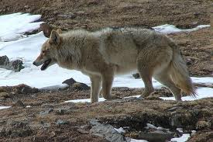
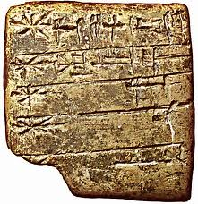
.006 MYA
Writing is developed in Sumeria
#1. How many million years ago was the Earth formed? _____________
Identify the four eras in order starting with the most present.
1.
2.
3.
4.
#2. How did the water for the oceans form? ____________________________________________________________________
Which era and period are we currently in?
Era- Period-
#3. 3500-2800 MYA the first prokaryotic organisms came into existence, do prokaryotes have a nucleus? Yes No
Name 4 types of events that could cause many organisms (plants and animals) to go extinct.
a.

b.

c.

d.

#4. How old could the oldest Eukaryotic multi-celled organism be? ________________
Which era is the longest? _________________
Which era is the shortest?_________________
#5. How many millions years between the first fossil and the first vertebrate fossil? _____________
In which eras and periods did the following first appear on Earth:
- Dinosaurs –

- Mammals –

- Flowering Plants –

- Birds –

#6. When did Algae begin to live on land? ____________ Why was it waxy coated? _______________________________________________________________________
Which developed first, plants or animals? ________________________________
#7. Which happened first, sharks for amphibians? ____________________
Why does that make sense? ______________________________________________________________________________
______________________________________________________________________________
#8. When did rooted plants first existed? ________________
Ferns first appeared in Period: ______________
Ferns first appeared in Epoch: ______________
#9. Could reptiles and insects have existed together at the same time? Yes No
Could reptiles and dinosaurs have existed together at the same time? Yes No
#10. What happened 200 MYA? _____________________________________________________
Which epoch: __________________________
#11. How long ago did dinosaurs go extinct? _____________
Which Epoch did mammals begin existence? ______________
#12. How long ago did the first bipedal hominid develop? _________________________
Using the picture on the gallery walk, what does bipedal mean? ____________________________________________________________________________
#13. When did Australapithecus Lucy walk on Earth? ________________________
Do you think this is the same as a present day human? Yes No
#14. How long ago did the last ice age occur? ________________________
Did man always use tools? Yes No
#15. How long ago did early man start to use fire? __________________
What epoch was this? ______________
#16. How long ago did the Homo sapien sapiens first evolve? ___________________
What epoch was this? _____________________
#17. How long ago was writing first developed? ________________________
Where do we find evidence of this? ___________________
