Watch It!
Watch the video and answer the questions. Link: http://studyjams.scholastic.com/studyjams/jams/science/forces-and-motion/inertia.htm
1. What is inertia?
2. What will happen to an object if it is put into motion in space?
a. It will stop eventually b. It will continue to move until it is acted on by an unbalanced force.
c. It will speed up over time d. It will slow down over time
3. An object at rest will remain at ________________, and an object in motion will remain in _______________ unless acted on by an external force.

Read It!
Read the provided article and answer the following 4 questions.
1. In the 1st paragraph the word resist means?
a. prevent b. allow c. accept d. surrender
2. What would be another good title for this passage?
a. The Story of Isaac Newton c. How Seatbelts Work
b. Newton’s 3 Laws d. An Explanation of Newton’s 1st Law of Motion and Inertia

Read It! (continued)
3. The author suggests inertia is most often experienced ____________?
a. when planets orbit c. at amusement parks
b. in moving and stopping vehicles d. when watching rockets launch
4. According to the article, what is one benefit of a seatbelt?
a. It keeps you from falling out of the car. b. It affects the inertia of the passenger
c. It allows you share the same motion as the vehicle d. They make you fly out of the car when stopping.
Read It! Article – The Law of Inertia
According to Newton's First Law, an object in motion continues in motion with the same speed and the same direction unless it is acted upon by an unbalanced force. This law is true of an object at rest, too. It will stay at rest unless acted upon by an unbalanced force.

It is natural for objects resist change. If you’re sitting on the sofa eating Doritos, it’s difficult to get off the sofa and ride your bike. When you ride your bike, Newton’s First Law will cause you to continue at the same speed and direction unless an unbalanced force slows you down, like gravity and friction. Newton’s First Law is often called the Law of Inertia.

Riding in cars is a good example of the Law of Inertia. The tendency of moving objects to continue in motion is a common cause of accidents. Consider the unlucky crash of a car with a wall. An unbalanced force (the wall) acts upon the car to suddenly slow it down to rest.

If the passengers are tightly fastened into their seatbelts, they will slow down to rest, too. This is because the passengers share the same “state of motion” as the car. As the car speeds up, the passengers speed up with it. As the car keeps a constant speed, the passengers stay a constant speed as well.

What happens if the passengers are not wearing the seat belt, and they crashed into the same wall? The passengers will no longer share the same state of motion as the car. If a seat belt is not worn, the passengers are more likely to keep moving forward as the car comes to a stop.

Research It!
Analyze the given information, watch the graphics, and answer the questions. Link: https://goo.gl/C4vfAZ (case sensitive)
1. In your own words, what does Newton's first law mean to you?
2. Why does the skateboarder continue to move forward when he hits the trash? What is the unbalanced force?
3. Come up with 3 of your own examples of how inertia can change when an unbalanced force acts upon it.
Research It! Text (in case you cannot read/see the website)
Use the provided Research It link above to view the moving objects.
According to Newton's first law...
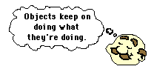
An object at rest will remain at rest unless acted on by an unbalanced force. An object in motion continues in motion with the same speed and in the same direction unless acted upon by an unbalanced force.
This law is often called "the law of inertia".
What does this mean?
This means that there is a natural tendency of objects to keep on doing what they're doing. All objects resist changes in their state of motion. In the absence of an unbalanced force, an object in motion will maintain this state of motion.
Observe Moving Graphic #1 and Think through the questions below. (You do NOT have to write the answers down).
What is the motion in this picture? What is the unbalanced force in this picture? What happened to the skater in this picture? This law is the same reason why you should always wear your seatbelt. (Observe Moving Graphic #2
Illustrate It!
Choose 1 of the examples you came up with for #3 on the Research It! Draw AND COLOR it on your answer sheet. (Distant Learners, please do this on paper and upload a picture of your illustration.
Explore It!
- You will need to collect a pencil, piece of paper, and something to make a ramp.
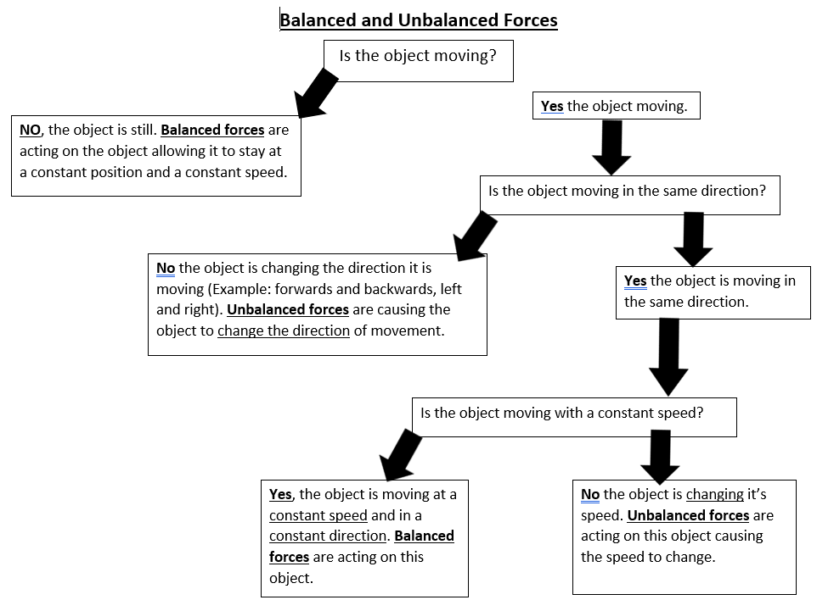
- Use the flow chart provided to help determine if Activities #1-3 represent BALANCED or UNBALANCED Forces.
Activity #1- Place the pencil on the table in
front of you. The pencil is sitting still and not
moving. Are balanced or unbalanced
forces acting on the object?
Activity #2- Slide a piece of paper across
the table. The paper should move at a
constant speed. Did balanced or
unbalanced forces act on the object?
Activity #3- Make a small ramp (large enough to roll a pencil down. You can use a binder or prop up a book.) and place the pencil at the top of the ramp. Allow the pencil to roll down the ramp. Did balanced or unbalanced forces act on the object? Explain what happened to the object as it rolled down the ramp.

