Fossil Fuels and Tectonic Plate Boundaries
Go to the following website: https://ourworldindata.org/fossil-fuels#per-capita-fossil-fuel-production-by-country-or-region
- Scroll down to the 13th chart titled “Oil Production by Country”. At the bottom of the chart click on the Map button. Use your curser to hover over the map and find the names to the countries.
- Which countries have the highest oil production (List 3): _____________________________________________________________________________________

- Press the play button on the bottom left of the map. Which countries always remained top oil producers? (List 3):_____________________________________________________________________________________

- Scroll down to the 22nd chart titled “Coal Proved Reserves 2015”. Use your curser to hover over the map and find the names of the countries.
- Which countries have the largest coal reserves? (List 3): ___________________________________________________________________________________________

- Coal is a sedimentary rock made from the remains of swampy plant material. It takes millions of years for this material to compress into coal. Finding large amounts of coal in an area gives scientists an idea of what the environment was like millions of years ago. What would the environment have been like millions of years ago in the areas of the world which currently have large coal reserves?
___________________________________________________________________________________________

- Scroll down to the 25th chart titled “Natural Gas Proved Reserves 2015”. Use your curser to hover over the map and find the names of the countries.
- Which countries have the largest natural gas reserves? (List 3): ___________________________________________________________________________________________

- What pattern can you draw between the leading countries of oil, coal, and natural gas? ______________________________________________________________________________________________________________________________________________________________________________________________

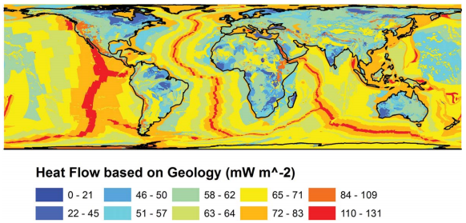
Tectonic plate heat map

Use the map above to answer the following:
- Describe where the most heat is concentrated on our planet. _______________________________________________________________________________________________

- What connection can be made between the location of fossil fuels and the concentration of heat on our planet. ______________________________________________________________________________________________________________________________________________________________________________________________
- AND What does this say about the conditions needed to form fossil fuels?
___________________________________________________________________________________________

