Fossils- Evidence for Plate Tectonics Name: _______________________________________ Date: _____________
Fossils are the remains or evidence of living organisms. Fossils come in different forms, including casts, molds, imprints, amber, and ice. Scientists can learn a great deal about life and the history of Earth using fossils. Fossils are useful evidence for understanding how organisms have evolved over time. They are also used to see how life has changed throughout Earth's history. Fossils have also been used to help scientists understand how the continents appeared millions of years ago. In this investigation, you will use several fossils to try to reconstruct how Earth's landmasses may have appeared approximately 250 million years ago.
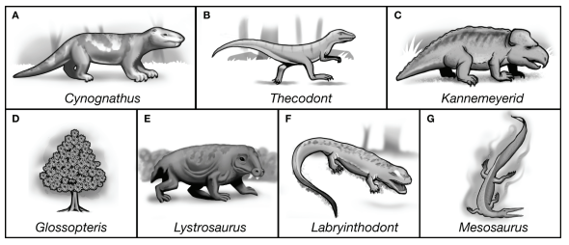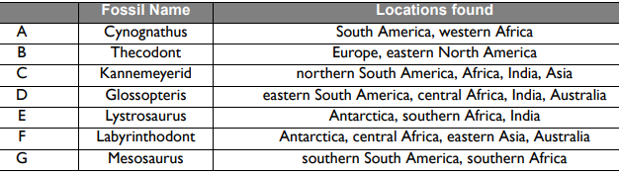
Mark the location of each fossil on the map below. Use the chart above and write the letter for each fossil on the correct continent. The locations in the table are approximate locations.
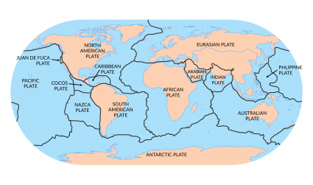

- Which of the fossils in the table are found on Antarctica?

- Which of the fossils on the table were found on North America and Asia?

- What are some ways these organisms could have traveled from continent to continent when they were living?

- If these animals and plants were not able to swim across large bodies of water such as oceans or sea, explain how else the pattern of fossil distribution can be explained.

- Glossopteris is an extinct type of plant referred to as a seed fern. These plants most likely thrived in tropical climates. Do any of the locations where the fossils of the glossopteris have been found seem strange? Which areas, and explain why those fossils would have been found in those areas?

- Thecodont was a small dinosaur. Where have fossils of this dinosaur been uncovered? Does it seem likely that this animal could have traveled between these two locations when it was living? Explain your answer.

- Explain how/why the fossils of Cynognathus could be found on two continents separated by a large ocean?

- If you were to move the continents to create the large supercontinent “Pangea”, which other continent(s) would Australia be closest too/connected too? Which fossils would be most helpful to determine your answer?

- What evidence/information provided by this activity might be useful for connecting the continents together into one giant landmass (Pangea)?

