Gravity in the Galaxies - Student Guide
Day 1: Engage – Phenomenon
In this task, you will explore what factors affect motion within our solar system.
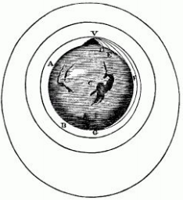
- Isaac Newton was very curious about what affects the motion of celestial bodies in our solar system. He presented a thought experiment called “Newton’s Cannonball,” in which he imagines a cannon on top of a very high mountain. Newton said that logically, the cannonball should follow a straight line away from Earth, in the direction it was fired, instead of falling.
- Do you agree? Why or why not?

- Developing and Using Models: Use the following simulation to engage with Newton’s cannonball thought experiment: http://physics.weber.edu/schroeder/software/NewtonsCannon.html

- If you set it to 1500 m/s, what happens? Explain why you think it moves this way.

- The moon orbits at 7,300 m/s. If you set the cannonball to this speed, what happens? Why is this different from the first setting?

- Now set it to 8000 m/s. What happens? How would you describe the relationship of an object’s speed and the force of gravity when it comes to orbits?

- Systems and System Models: You learned about gravity earlier this year. Gravity is the force that attracts objects towards physical bodies that have mass. Based on this definition, what object in our solar system do you think has the largest gravitational pull?

- How do you think this can explain the ways objects move in the solar system?

Day 2-3: Explore
Newton’s Cannonball is just one thought experiment which Isaac Newton used to hypothesize about the role of gravity in the motion of planets. Since then, scientists have used new technology to collect much more data that examines how objects move in the solar system. From this data, scientists have created models that not only describe current motions in the solar system but also how they started.
Systems and System Models: Explore the models below to form your own idea of how different parts of the solar system interact & why. Answer the questions that follow to help you describe each model.
Model 1: Simulating the Formation of Our Solar System
How did our solar system come to look the way it does? Before we simulate how the solar system was formed, we need to get some background. About 4.5 billion years ago, a dense cloud of gas and dust collapsed, forming a swirling disk of material. At the center, gravity pulled more and more material in until the pressure was so great that chemical reactions began releasing tons of energy. The sun was born from this interaction, using up 99% of the matter. However, matter farther out was also clumping together, forming larger objects. Some became planets, dwarf planets, and large moons. Others never quite came together and are part of the asteroid belt.
1. Visit the online simulation: http://www.nowykurier.com/toys/gravity/gravity.html
2. In the bottom left corner, click on “Huge” & then click “Generate proto disk (slow start)” to begin the sim.
3. Observe for approximately 30 seconds.
Discussion Questions
1. What appears to be happening?

2. What does this model imply as the main reason all of the planets orbit the sun?

Model 2: Simulating an Orbit with Our Bodies
This model simulates the motion of one planet in the solar system, so you can get a better feel for orbits.
1. Have one family member stand in the center holding one end of the rope or string. This person will represent the “Sun” and will not move from that spot, but will rotate or spin for the sake of this activity (Note: the sun does not actually rotate in reality).
2. You should hold the other end of the rope behind your back and start walking away from the motionless “Sun.” You will represent the “planet.”
3. You should revolve (walk) in a circle with the rope pulled taut until a full orbit is made around the “Sun”. Repeat the process several times.
Discussion Questions
1. When the rope becomes taut, what happens?

2. How does the pull of the rope affect the direction and motion (orbit) of the planet?

3.What do you think the force of the rope pulling on the “planet” represents?

Model 3: Simulating a Factor That Affects Solar System Movement
Now that we have a better idea of how our solar system formed and an example of a planet’s orbit, it’s time to think about what factors affect these motions.
1. Visit the online pHET simulation entitled “Gravity and Orbits”: https://phet.colorado.edu/en/simulation/gravity-and-orbits
2. Launch the simulation and select “Model.”
3. Click the selection showing the Sun, Earth, & Moon. Then click the boxes to show Gravity Force and Path.
4. Experiment with different masses of the Sun and Earth.
Discussion Questions:
1. How does the mass of the Sun impact the orbit of the Earth? Use an example from the simulation.

2. How does the mass of the Earth affect the Moon? Use an example from the simulation.

3.We learned that mass affects gravitational force. But how does this work in the solar system? Use examples from the simulation to explain how mass affects gravitational force in the solar system.

Day 4: Explain Using Models
The video shows a simulated solar system, created from authentic data on the solar system. Use the models you explored above to individually explain this simulation, describing the role of gravity in the motions within the solar system. In your explanation, you may want to:
❏ Describe the orbits of the planets
❏ Including what they are all orbiting around
❏ And why they are all in orbit
❏ Describe what factors and forces affect these orbits
Use evidence from the three models of the Explore to backup your explanation!

Day 5: Evaluate and Reflect
1. On Day 1 of this lesson, you used a thought experiment (Newton’s Cannon Ball) to think about why planets might move the way they do in our solar system. Look back at your response for Day 1. After completing this lesson, how would you add to or revise your responses? Use information from the models to improve your explanation of Newton’s thought experiment.

2. In this lesson, we focused on the crosscutting concept of Systems and System Models (models can be used to represent systems and their interactions). Where did you see examples of Systems and System Models in this lesson?

3. Now that you have used and developed models to describe the movement of celestial bodies in our solar system, what questions do you still have?

Optional Challenge:
You will now begin to brainstorm the best route a new telescope should take through space. After working through the lesson above you saw several different models of our solar system. During this you would have developed a better understanding for how objects within the solar system move in relation to each other due to gravity. Based on what you’ve learned about mass, gravity, and motion, you develop a potential route for a new telescope on a sketch of the solar system.
Background on the New Telescope
NASA’s new telescope will carry different science instruments to take pictures of and collect information about the physical characteristics and compositions of astronomical objects. One of the things it will look for is water and other clues about the potential habitability (ability to live) in another planetary system.
Instead of orbiting the Earth, as the current space telescope does, this telescope will orbit the sun! This gives it a spectacular view of objects in the solar system. With this view, it will be able to observe the water cycle on Mars, look at weather patterns on Saturn’s moon Titan, hunt for new rings around the giant planets, and track different comets.
As you consider your route, consider that the telescope needs to get to the outside edge of the solar system, past all of the planets. Take a look at the image below: This shows the final desired location of the new telescope, but keep in mind that this drawing is not to scale, and in reality, planets are not organized in a straight line. Once in place, the telescope will orbit the sun as quickly as Earth does. This keeps the telescope in line with the Earth, offering it a unique vantage point, and allowing the Earth to protect the telescope from most of the light and heat from the sun.
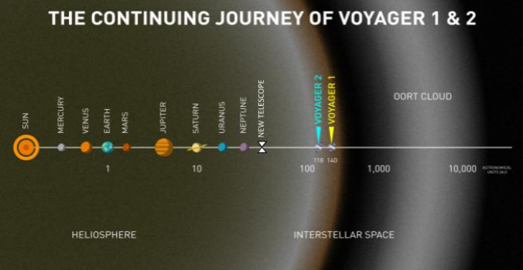

- Show and describe a potential route for the telescope within the model shown above.

- Explain what information in the tasks led you to choose this route.

