Mapping Earthquakes and Volcanoes
Instructions: Use the data chart below to map the location of earthquakes and volcanoes throughout our world. Place a on the map at the location of a volcano. Place a on the map at the location of an earthquake.
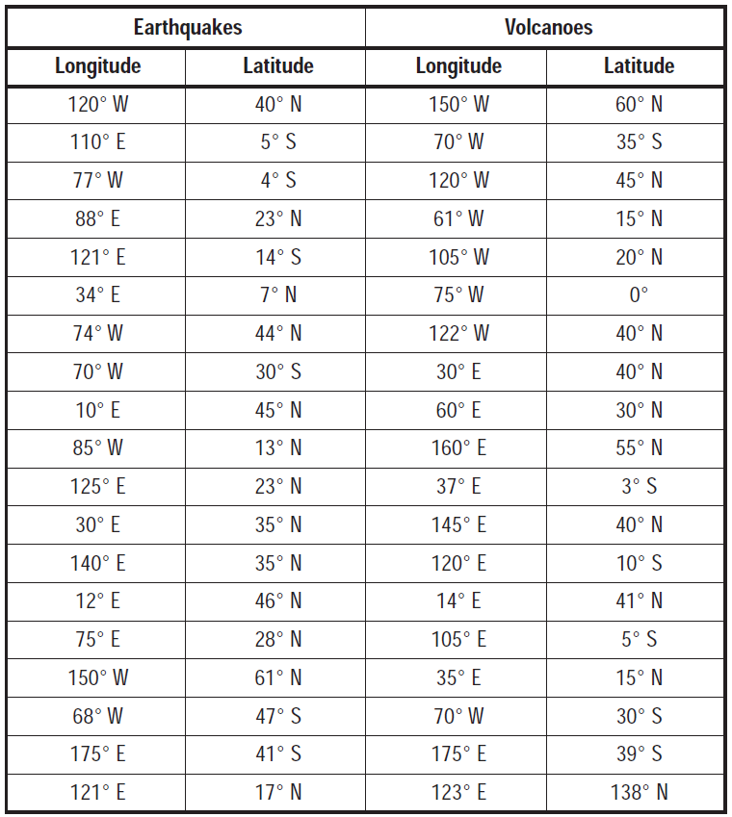
Answer the following AFTER you have mapped each earthquake and volcano.
- Explain the distribution of earthquakes across our planet.

- Explain the distribution of volcanoes across our planet.

- Explain the pattern between the location of volcanoes and the location of earthquakes.

- Explain the pattern between the location of volcanoes, earthquakes, and plate boundaries.

- Look at your data points for North America. What areas would be most at risk for earthquakes? Volcanoes?

- If you were an urban planner, engineer, or builder explain how the information on this map would be helpful to you. Be sure to explain exactly how you could use this map when planning new structures for your city.

