Tennessee Geologic Map
Excerpt from https://www.thoughtco.com/geologic-maps-of-the-united-states-4122863
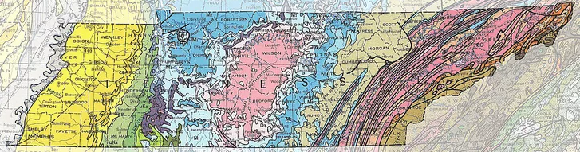
Geologic Maps of the 50 United States Created by Andrew Alden from the U.S. Geological Survey's Geologic Map of the United States, 1974, by Philip King and Helen Beikman

Tennessee's length extends from ancient granites in the Appalachian east to modern sediment of the Mississippi River valley in the west.
Tennessee is warped at both ends. Its western end is in the Mississippi Embayment, a very old break in North America's continental core in which rocks from modern to Cretaceous age (about 70 million years) are exposed in age order from gray to green. Its eastern end is in the Appalachian foldbelt, a mass of rocks wrinkled by plate-tectonic clashes during early Paleozoic time. The easternmost strip of brown is in the central Blue Ridge province, where the oldest rocks of Precambrian age have been pushed up and exposed by long erosion. To its west is the Valley and Ridge province of tightly folded sedimentary rocks that date from Cambrian (orange) through Ordovician (pink) and Silurian (purple) age.
In central Tennessee is a wide zone of fairly flat-lying sedimentary rocks on the Interior Platform that includes the Cumberland Plateau on the east. A low structural arch related to the Cincinnati Arch of Ohio and Indiana, called the Nashville Dome, exposes a large area of Ordovician rocks from which all overlying younger rocks have been removed by erosion. Around the dome are rocks of Mississippian (blue) and Pennsylvanian (tan) age. These yield most of Tennessee's coal, oil and gas. Zinc is mined in the Valley and Ridge, and ball clay, used in common ceramics, is a mineral product in which Tennessee leads the nation.

