Motion Map Practice #2 Name: __________________________________
Instruction: Depict the movement in each scenario using a motion map and a time position graph.
- Sherman ran at a spend of 3 m/s for 3 seconds to the end of the drive way. He picked up the newspaper and three seconds later he walked back. It took 9 seconds to walk back to the house.
Click here to see a video of example of #1

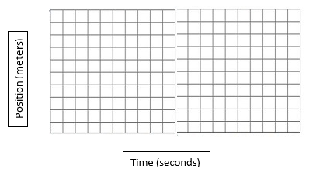

- Nathan and Lindsay were painting a 20m wall in their living room. Nathan tossed a painted brush to Lindsay and she caught it 4 seconds later. Lindsay then walked with the brush to the middle of the wall at 2 m/s. Click here to see a video example of #2.

- Adam climbed 5m up a ladder After 5 seconds he was standing on the middle rung of the ladder. Adam was too scared of heights to climb any higher so he climbed back down after 3 seconds at the same speed. Click here to see a video example of #3.

- Jacob and Henry were playing catch. Jacob threw the ball 20m to Henry at a speed of 2m/s. Henry held the ball for 2 seconds and threw the ball back at a speed of 2.5 m/s. Click here to see a video example of #4.

- Josh rolled in his office chair to the door in 6 seconds. He talked to Samantha for 4 seconds. He then rolled 6m back to his desk in 6 seconds.

- The object move in the positive direction at a steady speed for 5sec, reverses direction and moves back toward the negative direction at the same speed.

- The object stays in place for 5sec, moves in the positive direction at a steady speed for 5sec, reverses direction and move back toward the negative direction at the same speed for 5sec.

