Newton’s 2nd Law Tasks (Answer Sheet) Name: ___________________________________ Date: _______________
I recommend to complete the tasks in the following order: Read it, Watch it, Explore it, Illustrate it.
Read It
Free Body Diagram Article
Question 1 Question2
F_{A} –

F_{F} – Question 3

F_{N} –

F_{G} –
The Law of Acceleration Article
1. _______________ 2.______________________

3.________________

Illustrate It
Question #1 Question #2
1. 2.

Question #3 Question #4
3. 4.
Watch It
Question 1

Question 2

Question 3
Explore It
Task #1
1.

2.

Task #2
1.

2.
Explore It!
Materials: golf ball, ping pong ball, and a small container of sand
(Golf ball and ping pong ball can be substituted for any two spheres with a similar size, but different masses. Sand can be substituted for loose dirt, clean kitty litter, play-duh or slime)
Before you begin: Place a small about of sand (1-2inches) in the bottom of a container. A wide bowl, baking pan, or plastic Tupperware container will all work fine. Make sure the surface of the sand is level/flat.
Task 1
- Place both the golf ball and the ping ball side by side on the table in front of you. Attempt to move the golf ball by blowing 1 big breath of air on it. Do not touch the golf ball with your mouth.
- Attempt to move the ping pong ball by blowing 1 big breath of air on it. Do not touch the sphere with your mouth.
Questions:
- Why did one sphere accelerate faster?
- What do you think would happen if we added a third sphere with more mass?
Task 2
- Place the container of sand in front of you. Level the surface of the sand.
- Hold both the spheres above the sand, one sphere in each hand. Hold the spheres approximately 20cm above the sand.
- Allow the sphere to drop onto the surface of the sand. Carefully remove the spheres from the sand without disturbing the sand’s surface.
- Observe the crater left in the sand.
Questions:
- Describe each of the craters left behind.
- Why is one crater deeper than the other?

Watch It!
1. Go to: https://www.youtube.com/watch?v=4Bwwq1munB0
2. Press Play
3. Answer questions 2-4.
4. You only have to watch examples 1-3!!!!!
Questions:
- Follow along with the speaker on the video and draw the example free body diagram for #1. Make sure you draw the box and label both arrows. Pause the video when you need to copy the screen.
- Watch example #2. How do you know the forces acting on the box are unbalanced?
- Follow along with the speaker on the video and draw the example free body diagram for #3. Make sure you draw the box and label all 4 arrows. Pause the video when you need to copy the screen.
Read it! (Free Body Diagram Article)

What is a Free-Body Diagram and How to Draw it (with Examples)
In this article, you will learn what a free-body diagram (or FBD) is, and how to draw it in 3 simple steps.

What is a free-body diagram?
A free-body diagram is a representation of an object with all the forces that act on it. The external environment (other objects, the floor on which the object sits, etc.), as well as the forces that the object exerts on other objects, are omitted in a free-body diagram.
Below you can see an example of a free-body diagram:
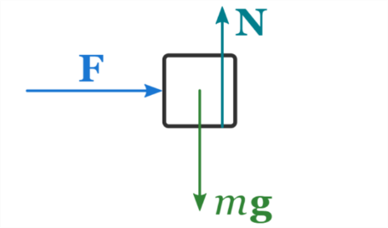
Free-body diagrams are important because they allow us to analyze an object in isolation without distractions.

How to draw a free-body diagram?
You can draw a free-body diagram of an object following these 3 steps:
- Sketch what is happening
- Determine the forces that act on the object
- Draw the object in isolation with the forces that act on it
Let's go through these steps in more detail.

Step 1: Sketch your FBD Outline
This simply means that after you've read the problem once or twice, you sketch the object (box), and draw 4 arrows coming out from the center of the box to represent forces (e.g. the push or the pull exerted by somebody, the friction force, gravity and normal force) .

Step 2: Determine the forces that act on the object
Carefully observe your sketch, and think about all the forces that are acting on the object.
Returning to our example: the block is pushed, so a applied force acts on the block; there is friction between the block and the floor, so a friction force acts on the block (opposing its motion); the block is subject to the force of gravity; the floor exerts the normal force on the block in order to prevent the block from falling through the floor due to the force of gravity.
Therefore, we come to the conclusion that 4 forces are acting on our block:
- the applied, F_{A}
- the friction force, F_{f}
- the normal force, F_{N}
- and the gravitational force Fg

Step 3: Draw the object in isolation with the forces that act on it
Finally, draw the object on its own (omitting external elements like other objects, the floor, the ceiling, etc.) and the forces that are acting on it.
In our example, we draw the block and the 4 forces that act on it.
F_{A}
F_{f}
F_{g}
F_{N}

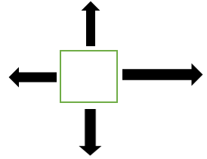

Questions:
- Explain each of the 4 forces depicted on a FBD.
- Sketch the FBD shown in Step 3.

Read It! (Newton’s Second Law Article)
Newton’s second law of motion is stated as follows: The acceleration of an object as produced by a net force is directly proportional to the magnitude of the net force, in the same direction as the net force, and inversely proportional to the mass of the object. Another way to write this would be to use the equation Force = Mass X Acceleration or F=MA
The acceleration of an object depends directly upon the net force acting upon the object, and inversely upon the mass of the object. As the force acting upon the object is increased, the acceleration of the object is increased. As the mass of an object is increased the acceleration of the object is decreased.
For example, one soccer player could kick a 400kg soccer ball, and it accelerates at 5m/s². His force would be 2000N.
Another soccer player could kick the same 400kg soccer ball, but it accelerates at 10m/s². His force would be 4000N.
The ball traveled much faster in the second scenario because the soccer player applied a greater force to the soccer ball, which had the same mass.
Questions:
- Write the formula associated with Newton’s second law.
- If the force applied to the object increases the acceleration of the object will ________.
- What is the net force acting on a 15kg sled accelerating at 5m/s?
Illustrate It!
This needs to be the last task completed. Answer these questions last!
- Label the following forces on the correct arrows: gravity, normal force, force applied, friction.
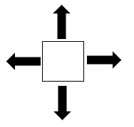

- A textbook is being pushed across the desk to another student. Student 1 pushes the textbook with a force of 20N towards Student 2. The book is experiencing 10N of friction. Draw the free body diagram to illustrate the forces on the book. (Hint: You should have 4 labeled arrows, but the arrow from the applied force may be longer than the arrow of the friction force). Click here for a video example.

- Jeremy pushes a ball across the floor. Jeremy applies 10N of force in a rightward direction. The ball experiences 5N of friction. Draw the free body diagram to illustrate the forces on the ball. (Hint: You should have 4 labeled arrows, but the arrow from the applied force may be longer than the arrow of the friction force). Click here for a video example.

- Henry pushes a cart down the hallway. He pushes with 50N of force. The wheels of the cart experience 10N of friction. Draw the free body diagram to Illustrate the forces on the cart. (Hint: You should have 4 labeled arrows, but the arrow from the applied force may be longer than the arrow of the friction force). Click here for a video example.

