Patterns of Natural Resources Name: _____________________________________________________ Date: __________ Period: ____
Use the maps to answer the following questions:
1. Do you notice the majority of mining sites and volcanic activity on the edges of continents or the middle? ___________________________________________
2. Are any mining sites in water? __________________________ Are any volcanic activity areas in water?_____________________________________________
3. Compare maps 1 and 2. What do you notice about the location of the active volcanoes and copper mining sites? _____________________________________
______________________________________________________________________________________________________________________________________________________________________________________________________________________________________________________________________
4. Sketch the tectonic plates onto the top of the Copper Mining map.
5. How would you describe the global supply of copper? _____________________________________________________________________________________
___________________________________________________________________________________________________________________________________
6. What continents have the largest supply of copper? ______________________________________________________________________________________
7. What region(s) in the United States has a concentration of copper, and why might this be? _______________________________________________________
___________________________________________________________________________________________________________________________________
8. What does concentration mean? ______________________________________________________________________________________________________
9. What are the benefits of having minerals concentrated in one place rather than scattered all around? ______________________________________________________________________________________________________________________________________________________________________________________________________________________________________________________________________
11. What connection can you draw between the location of volcanoes, copper mining sites, and plate boundaries? ______________________________________________________________________________________________________________________________________________________________________________________________________________________________________________________________________
10. Use Earth’s Mineral Resources Map (on back) What conclusions can you draw about the distribution of natural resources around our planet? _________________________________________________________________________________________________________________________________________________________________________________________________________________________________________________________________________________________________________________________________________________________________________________________________________

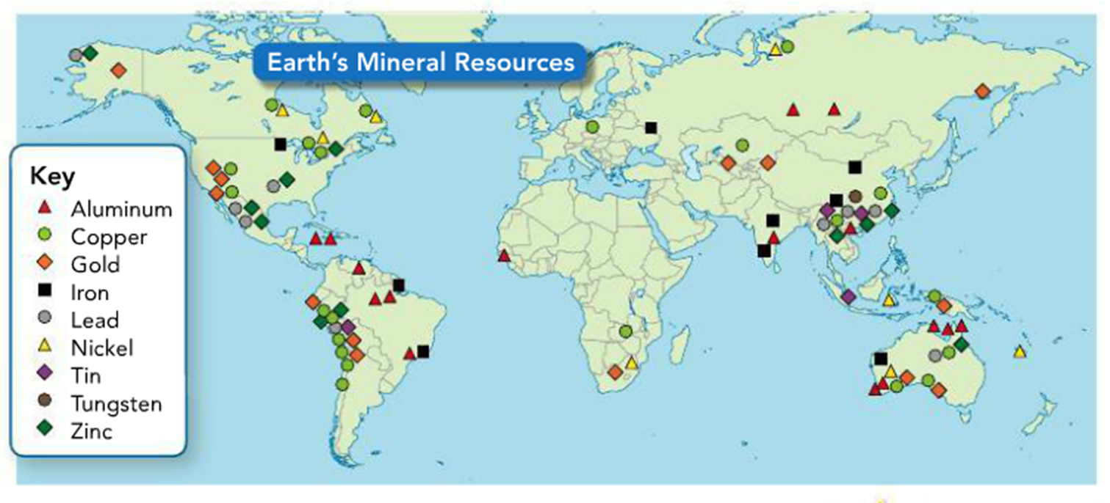

Using the map above (Earth’s Mineral Resources) write 3 questions based on patterns you see between the location of minerals and plate boundaries.
#1_________________________________________________________________________________________________________________________________
___________________________________________________________________________________________________________________________________
#2_________________________________________________________________________________________________________________________________
___________________________________________________________________________________________________________________________________
#3_________________________________________________________________________________________________________________________________
___________________________________________________________________________________________________________________________________
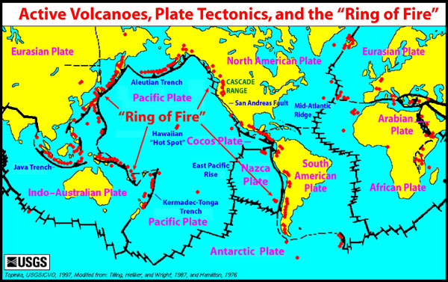

Copper Mining Around the World Map 1
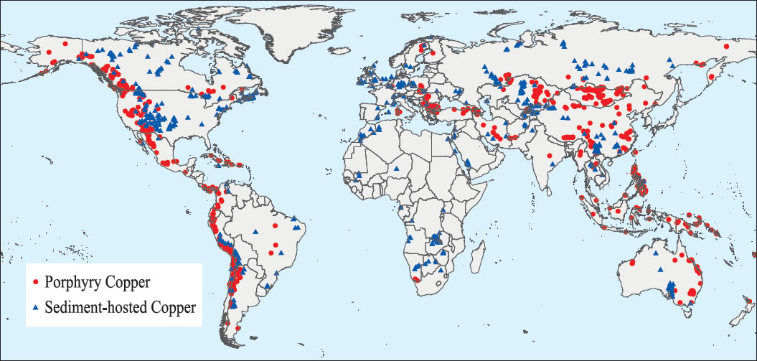

Plate Boundary and Volcanoes Map 2
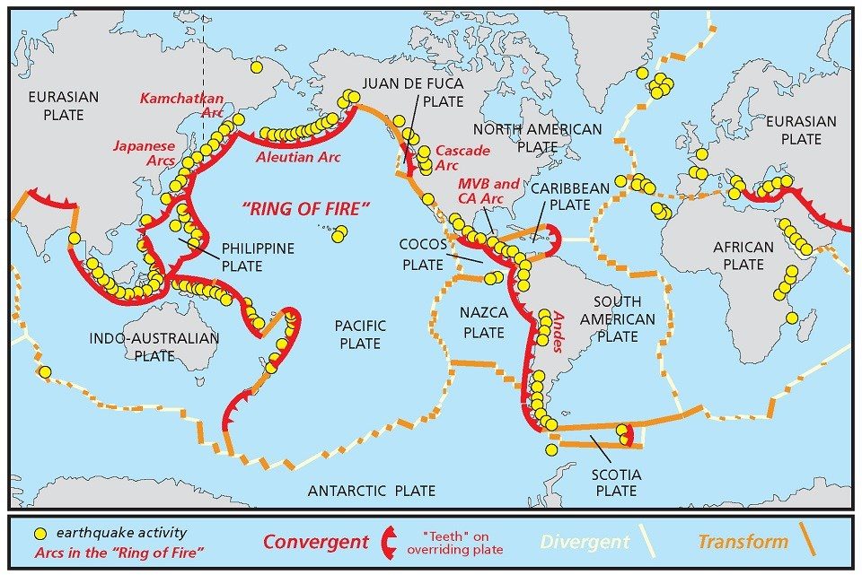
Volcanoes

Comments about Including the Performance Expectation
In this resource, students compare two maps: one of world-wide copper distribution locations and another displaying plate boundary volcanism. Through careful observation and analysis, students will discover that most copper ore deposits are located near areas of past tectonic activity. Conversely, students will also conclude that regions lacking in tectonic activity also lack significant concentrations of copper ore. Students may ask why copper deposits are located near areas of tectonic activity. Teachers can direct students to the following website for information:
Ask students to brainstorm ten objects they interacted with that day. Examples may include food, clothing, electronics, school supplies, and drinks. If students are unfamiliar with the term “mining,” share the images of an open pit and underground mine. Share examples of minerals that might be mined at those sites, including gold, copper, and molybdenum. Direct students to evaluate their lists and identify which objects are naturally growing and which have been mined. For example, food items and water are naturally occurring whereas their electronics would include items that are mined, such as gold and copper (note that naturally occurring items need products of mining for human use; i.e., food requires equipment for harvesting and planting and water generally needs piping and pumps for distribution). Clarify that many of our everyday items come from minerals that are mined and are then made into products.

http://www.australianminesatlas.gov.au/education/down_under/copper/formed.html

Ask students if they use a computer, talk on the phone, use door handles, ride in a car, use coins, or use lights. These resources could also be displayed visually for students. Explain that all of these objects are made from copper and ask students where they think copper comes from.
Distribute the maps of copper mining areas, plate boundaries and active volcanoes.

