Red Shift, Blue Shift Name: ________________________________________ Date: ______________ Period: ____

1.How can you estimate the speed of a car that has passed you just by listening to the pitch of its whine?

2. Label the diagram below from the observes point of view (pitch is higher, lower, or constant).

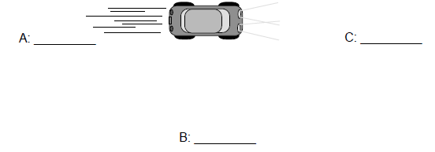

(observer)
3. Compare the pitch heard by the observer to the pitch heard by the driver.

4. If the Car increases speed as it travels toward point C how would that change the pitch

5. How does the doppler shift affect the color of a star?

6. Describe how astronomers can use the doppler shift to determine if a star is moving toward us or away?

7. How can Red Shift be used a supporting piece of evidence for the Big Bang Theory?

