Rock Cycle Melting Lab
This activity REQUIRES parent approval and supervision. Students, DO NOT attempt any of this activity by yourself!
The rock cycle is a never-ending process. Igneous rock forms from magma or lava. Weathering breaks
igneous rock into sediments such as pebbles and sand. These small pieces are compacted and cemented
under pressure into sedimentary rock. Under great heat and pressure inside the Earth’s crust, igneous
and sedimentary rocks are changed into metamorphic rocks. These rocks are brought to the earth’s
surface where they are weathered again into sediments to become sedimentary rocks.
Materials
hot plate 10 milk chocolate chips 10 white chocolate chips
10 butterscotch or peanut butter chips plastic knife, paper plate sheet of aluminum foil heavy books

** Materials can be substituted: Instead of chocolate/butterscotch chips you can use three different colored crayons or different colored wax melts.

Safety Concern: The hot plate will cause burns. Use it carefully. (A stove eye can be used instead of a hot plate. A microwave can be used IF YOU DO NOT USE ALUMINUM FOIL. Do not place metal in the microwave.

Part 1 Making Sediment Procedure
A. Pour one color of chips on the plate and cut them into little pieces and shavings with the plastic
knife. (The smaller the pieces and shavings, the better)
B. Pour the little pieces and shavings on to the aluminum foil.
C. Take another color of chips and cut them up into little pieces.
D. Pour the little pieces and shavings on top of the other color on the foil.
E. Repeat with the last color.

1. What process does this represent in the rock cycle. (Hint you can use the rock cycle diagram below to help if needed)
_______________________________________________________________

2. Draw and color what you see from the top. 3. Draw and color what you see from the side.

Part 2 Making Rock Type #1
A. Fold the aluminum foil over your three layers of chips.
B. Place two or three heavy books over the aluminum foil and leave for 3 minutes. Then push down on the books for 1 min.
C. Take off the books and observe the chips.
4. What type of rock has been created from the compaction of the pieces. ______________________
Describe how this typically happens in nature.
_______________________________________________________________
_______________________________________________________________
_______________________________________________________________

5. Draw and color what you see from the top. 6. Draw and color what you see from the side.

Part 3 Making Rock Type #2
A. Fold the aluminum foil over the chips again.
B. Use your hands to press the aluminum foil and the chips inside. Use both hands to message and knead the aluminum foil. Continue this for approximately 3 minutes.
E. Unwrap the aluminum foil and observe the chips.
7. What processes in the rock cycle did you represent by pressing the foil with your hands.
_______________________________________________________________
What type of rock is created by these processes? _______________________

8. Draw and color what you see from the top. 9. Draw and color what you see from the side.
Part 4 Making Rock Type #3
A. Wrap the aluminum foil over the chips again.
B. Take the foil package to a hot plate and lay it on the hot plate for 30-45 seconds. (if you are using a microwave, transfer the chips into wax paper or a paper bowl)
C. Pick up the package by the sides and return it to your table.
D. Leave the package wrapped for at least 10 minutes.
E. Gently unwrap the aluminum foil and observe.
10. What process in the rock cycle were represented?
_______________________________________________________________
What type of rock is created by these processes? ____________________

11. Draw and color what you see from the top. 12. Draw and color what you see from the side.

Questions
13. What did you do to simulate weathering rocks?
_______________________________________________________________
14. What did you do to make the sedimentary rocks stick together?
_______________________________________________________________
15. What did you do to make the metamorphic rocks stick together?
_______________________________________________________________
16. What was the difference between what you did to the sedimentary rocks and what you did to the
metamorphic rocks?
_______________________________________________________________
17. What did you do to make the igneous rocks?
_______________________________________________________________
18. What was different between what you did to the metamorphic rocks and the igneous rocks?
_______________________________________________________________
Remembering the information you learned in this lab, fill in the following flow chart.
Use the following words: Sedimentary Rocks, Metamorphic Rocks, Igneous Rocks
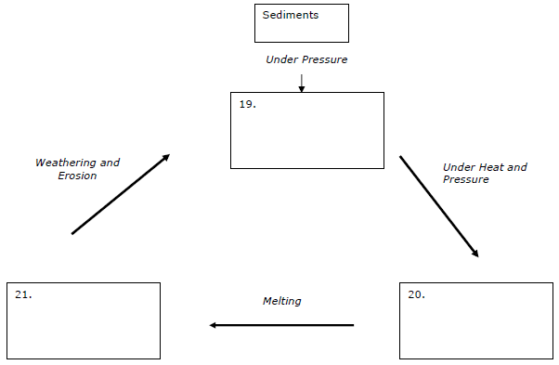

Answer Key - DO NOT use this page until you have attempted all the questions above.
- Weathering and Erosion.
- 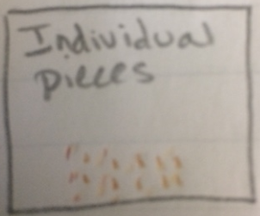 3. 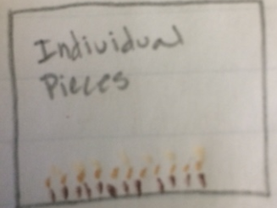
4.Sedimentary Rock; In nature sedimentary rocks are compacted by the pressure created from layers of sediment over long periods of time. As sediment layers from the weight of the layer pushes down on the layers beneath. Eventually the layers will become cemented together.
5. 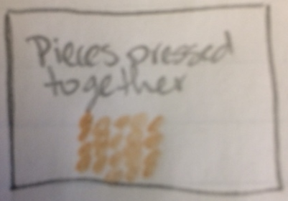 6. 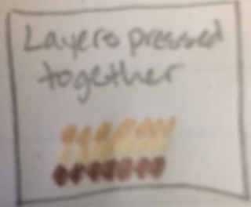
7. Heat and pressure; Metamorphic
8. 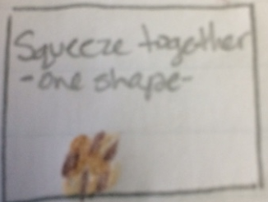 9. 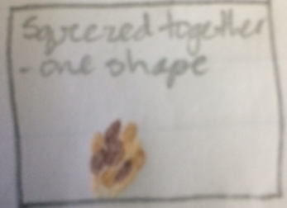
10. Melting; Igneous Rock
11. 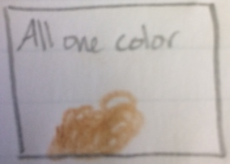 12. 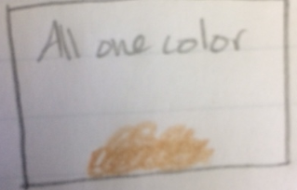
13. Cut the chips into small pieces.
14. Use the weight of the book to press down on the pieces
15. Use the heat and pressure of your hands
16. The sedimentary rock formed from indirect pressure of its surroundings and the metamorphic rock formed from direct pressure of your hands and a small amount of heat from your hands.
17. melted the material and allowed it to cool
18. The metamorphic rock formed from direct pressure and a small amount of heat, but the material didn’t full melt. The igneous rock formed from direct heat which caused the material to melt.
19. sedimentary
20. metamorphic
21. igneous

