1. Draw your model of the inner structure of the Earth as you did with your partner in the space below and label the layers.

2. Based on the data that was provided, what patterns or changes in patterns did you see?

3. How did these patterns help you develop your model?

4. Which model of the Earth below is more accurate according to our data and why?

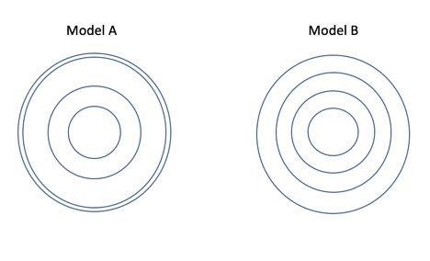

5. What is another model of the Earth you could use?

Page 3
Creating a Model of the Structure of the Earth
Seismic Wave Data

A. Analyze the data in the table and draw lines between depths where you see changes in the pattern of the speed of the wave.

Seismic P and S Wave Data

Wave Type | Depth  (km) | Speed  (km/s) |  | Wave  Type | Depth  (km) | Speed  (km/s)
P | 0 | 6 |  | S | 0 | 3.5
P | 50 | 9 |  | S | 50 | 5
P | 200 | 8 |  | S | 200 | 4
P | 500 | 9 |  | S | 500 | 5
P | 1000 | 11 |  | S | 1000 | 6
P | 2000 | 13 |  | S | 2000 | 7
P | 2900 | 14 |  | S | 2900 | 7.5
P | 2900 | 8 |  | S | 2900 | 0
P | 4000 | 9 |  | S | 4000 | -----------
P | 5200 | 10 |  | S | 5200 | -----------
P | 5200 | 11 |  | S | 5200 | -----------
P | 5500 | 11 |  | S | 5500 | -----------
P | 6000 | 11 |  | S | 6000 | -----------
P | 6400 | 11 |  | S | 6400 | -----------

Page 1
B. Analyze the graph and draw vertical dotted/dashed lines through the graph where you see changes in the pattern of the speed of the waves. Take note of the depth at which these speeds change.
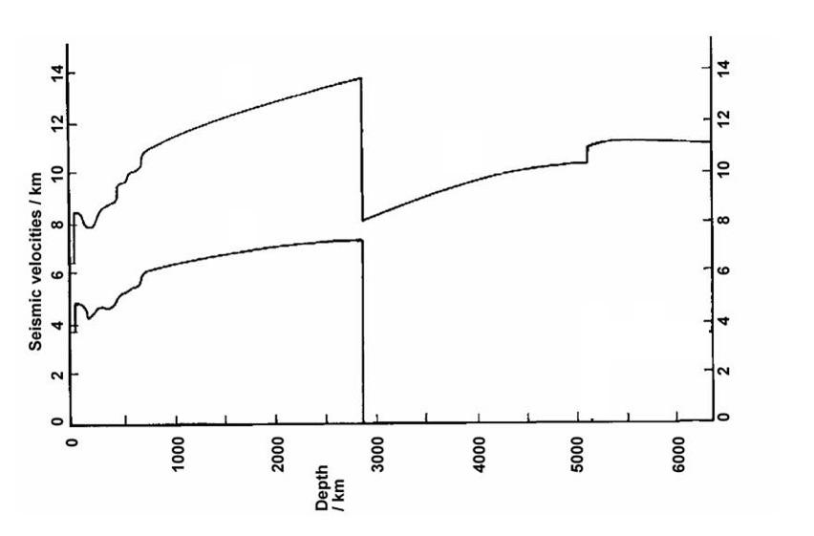

C. Agree on a design for a model for the composition of the Earth’s layers in the form of a two-dimensional diagram, and draw it below. The layers should be drawn proportionally correct (within reason and estimations), and each layer should be labeled.

Page 2

