Seymouria Fossil

Characteristic
Bat
Rat
Frog
Pigeon
Lizard
Seymouria
Analysis of Data: (create a cladogram using your characteristic chart)

Which group of modern animals could the Seymouria Fossil be an ancestor of based on similarities in body structure?
Claim: (answer to the question)

Evidence: (information to support your claim) | Reasoning: )justifies and explains how the evidence supports your claim)

Bat Frog Fossil
Fossil
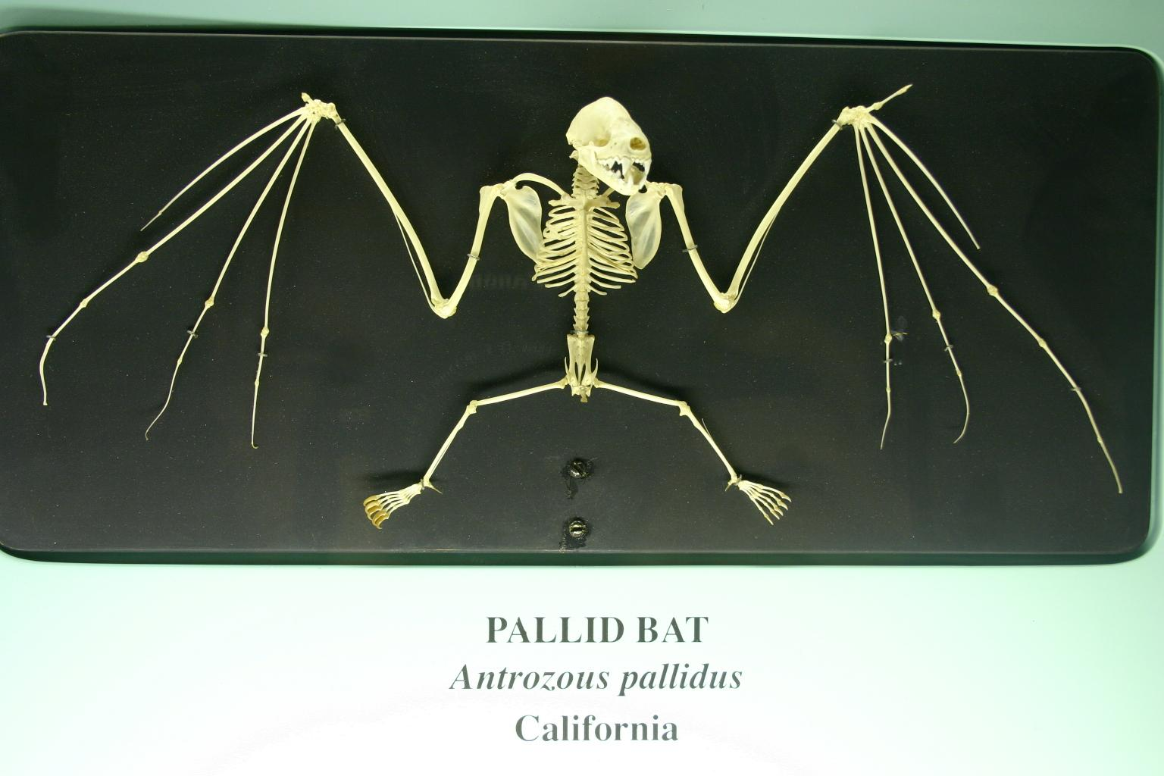
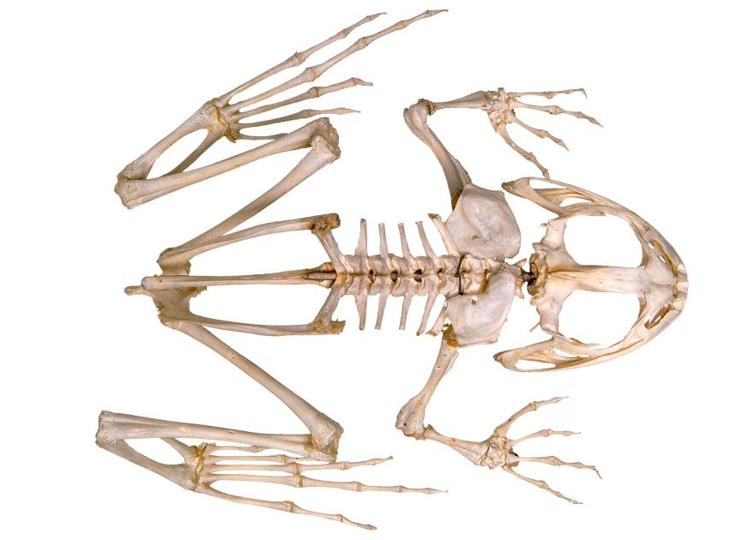

Rat Fossil

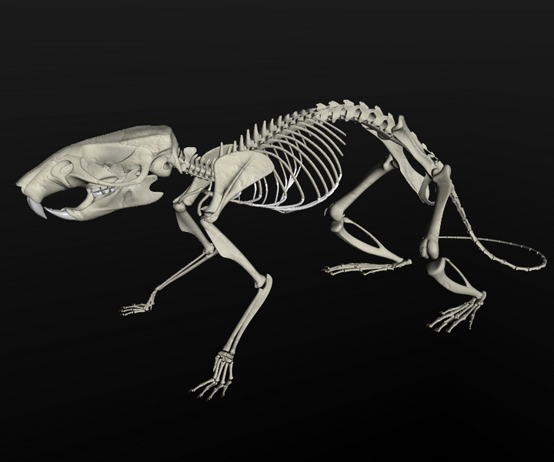
Rat
Fossil

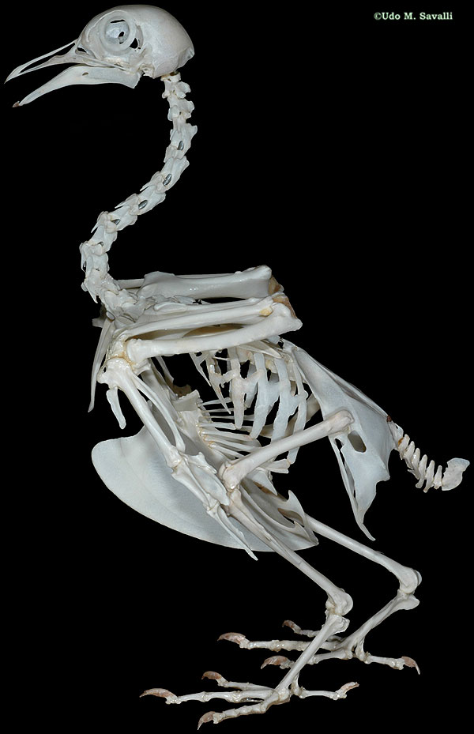
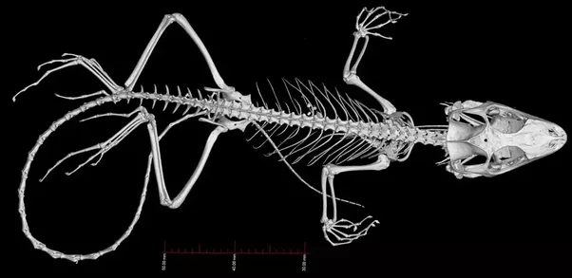
Lizard Fossil Pigeon Fossil

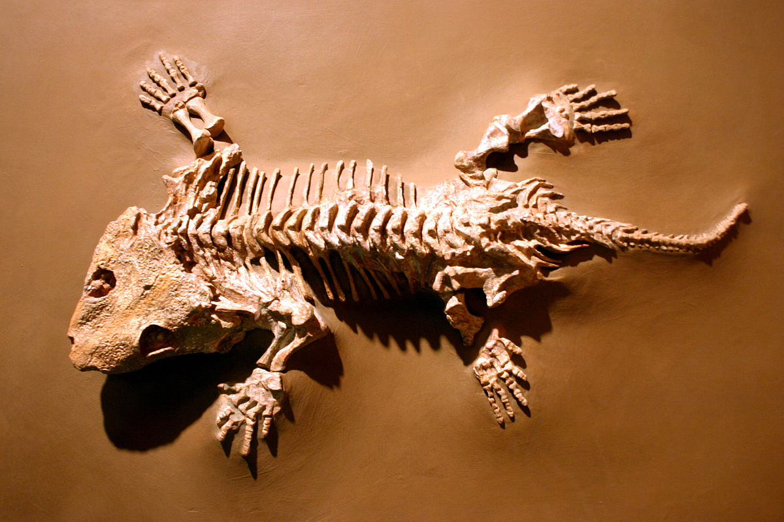
Seymouria Fossil

