Universe Formation Tasks Name: ___________________________________________ Period: __________
Please complete the tasks in the following order: Read it#1, Read it #2, Match it, Explore it, Watch it, Research it, and Write it.
Match It
Unknow Star A:

Unknown Star B:

Read It #2 (Textbook)
Write your answers in your textbook.
Read It #1 (CMB Article)
- ______
2. ______
3. _____
4. _____
Explore It
#1- Smaller balloon with 1 breath of air
Distance Point 1 to Point 2 ___________

Distance Point 1 to Point 3 ___________

Distance Point 1 to Point 4 ___________

Distance Point 1 to Point 5 ___________

Distance Point 1 to Point 6 ___________

#2- Larger balloon with 2 breaths of air
Distance (cm) Point 1 to Point 2 ___________

Distance Point 1 to Point 3 ___________

Distance Point 1 to Point 4 ___________

Distance Point 1 to Point 5 ___________

Distance Point 1 to Point 6 ___________
#3 ______________________________________________________________________________________
#4 ______________________________________________________________________________________
#5 ______________________________________________________________________________________
#6 ______________________________________________________________________________________
#7 _________________________________________

Research It
1._________________________________________________________________________________________________
2.________________________________________________

3._________________________________________________________________________________________________
4._________________________________________________________________________________________________
5.________________________________________________

6._________________________________________________________________________________________________
7._________________________________________________________________________________________________
Watch It
#1 ___________________________________________

#2 ___________________________________________

#3 ____________________________________________

#4 ____________________________________________

Assess it!
#1 ______
#2 ______
#3 ______
#4 ______
Write It
#1
________________________________________________________________________________________

#2
Element Name: ______________ Percentage: ____%
Element Name: ______________ Percentage: ____%
Element Name: ______________ Percentage: ____%
#3
- _________________________________
- _________________________________
- _________________________________

Read it! #1 (CMB Article)
Directions: Read the article below and answer the questions that follow.
Cosmic Microwave Background (CMB)
The Cosmic Microwave Background radiation, or CMB, is a faint glow of light that fills the universe, falling on Earth from every direction with nearly uniform intensity. It is the leftover heat of creation--the afterglow of the big bang--streaming through space these last 14 billion years. Since the early twentieth century, two concepts have transformed the way astronomers think about observing the universe. The first is that it is fantastically large; the portion of the universe visible today is a sphere nearly 15 billion light-years in radius, and that, we believe, is just the tip of the iceberg. The second is that light travels at a fixed speed. A simple consequence of these ideas is that as you look at more and more distant objects, you're seeing farther and farther back in time-- sometimes very far back indeed. When you see Jupiter shining in the night sky, for example, you're looking about an hour back in time, whereas the light from distant galaxies captured by telescopes today was emitted millions of years ago. The CMB is the oldest light we can see--the farthest back both in time and space that we can look. This light set out on its journey more than 14 billion years ago, long before the Earth or even our galaxy existed. It is a relic of the universe's beginning, a time when it was not the cold dark place it is now but was instead a firestorm of radiation and elementary particles. The familiar objects that surround us today--stars, planets, galaxies and the like—were eventually created from these particles as the universe expanded and cooled. This leftover radiation is critical to the study of cosmology because it contains the fossil imprint of those particles, a pattern of very tiny intensity variations from which we can decipher the vital statistics of the universe, like identifying a suspect from his fingerprint. When this cosmic background light was released billions of years ago, it was as hot and bright as the surface of a star. The expansion of the universe, however, has stretched space by a factor of a thousand since then. The wavelength of the light has stretched with it into the microwave part of the electromagnetic spectrum, and the CMB has cooled to its present-day temperature, something the radio telescopes register at about 2.73 degrees above absolute zero.
Questions:
1. What is the best description of the CMB?
A. Energy from the Sun measured in microwaves
B. The chemical composition of Hydrogen and Helium
C. Residual energy leftover from the origin of the universe
D. Evidence that galaxies are rapidly moving apart
2. How do scientists study light from 14 million miles away?
A. Wavelengths using the electromagnetic spectrum
B. Temperature using a thermometer
C. Chemical composition using a microscope
D. Reflection of light using a mirror
3. Microwaves from the CMB are considered to be the _________ in the universe.
A. lowest frequency B. highest frequency C. newest D. oldest
4. When the universe originated the light was _______, and as space expanded it ________ to its current temperature.
A. hot and bright; cooled B. cool and bright; heated
C. hot and dim; cooled D. cool and dim; heated
Read it! #2
Directions:
- Turn to textbook Pg 260 and read Chemical Composition on Pg 260. Answer A,B,C in Apply it.
- Read Brightness of Stars on Pg 261. Answer the Challenge (in the white box on left hand side of page)
- Read What is an HR Diagram… Pg 262-263. Complete the blue chart for star A,B,C. Then place a dot on the HR diagram to represent star A, then a second dot to represent star B, and a third dot to represent star C.

Match It!
Scientists use different types of waves to identify composition of distant stars and planets. Each star or planet will emit different kinds of electromagnetic waves which can be matched up to known elements on Earth. This is how we know what stars are made up of.
Directions:
You will be using the light spectrums to find the elements which make up 2 Unknown Stars.
Star A- below you can see the light emission spectrum from Star A. This star is made of several elements. You will determine which elements are combined to make star A. Use the black lines on Star A and match them to the black lines on the provided element light spectrums. Once you have combined the correct elements together all the black lines should match the lines on Star A.
Unknow Star A light spectrum: (Hint star A is the combination of 4 elements)
Known Elements:
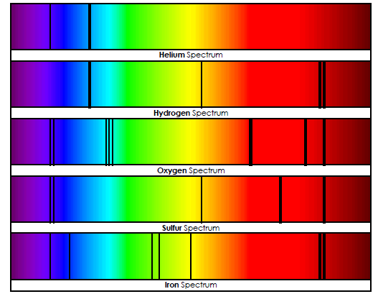

Unknown Star B light emissions: (Which of the known elements above are combined to make Star B?)
Explore it!
Click here to access the demonstration video.
Questions:
- Use the small balloon and measure the distance between dot 1 and each other dot.
- Use the large balloon. Two breaths of air were used to inflate the balloon, but the dots and their locations are the same. Measure the distance between dot 1 and each other dot.
- Look at the data you have recorded on #1 and #2. Explain the pattern or trend with the numbers.
- The balloons are meant to be a model in order to help explain a theory. What theory do the balloons help model?
- What do you expect to happen to the dots if you added more air into the balloon?
- A scientist, Edwin Hubble, noticed that galaxies which are farther away from us have a light spectrum which has longer wavelengths and is on the red end of the spectrum. This is called redshift. He concluded that galaxies are moving away from each other at an increasing rate and that the universe is expanding. The movement of galaxies is only one piece of evidence that supports the Big Bang Theory. When the universe began, the first elements created where Hydrogen and Helium. Look at the periodic table. Why do you think Hydrogen and Helium were the first atoms to form?
- Scientists are able to determine that all of the visible mass in the universe is composed of about 73% Hydrogen and 25% Helium. The remaining 2% are all other elements. The composition of the universe is the second piece of evidence that supports the Big Bang Theory. You have already read about the third piece of evidence during the Read it #1 task. What is the third piece of evidence used to support the Big Bang Theory?
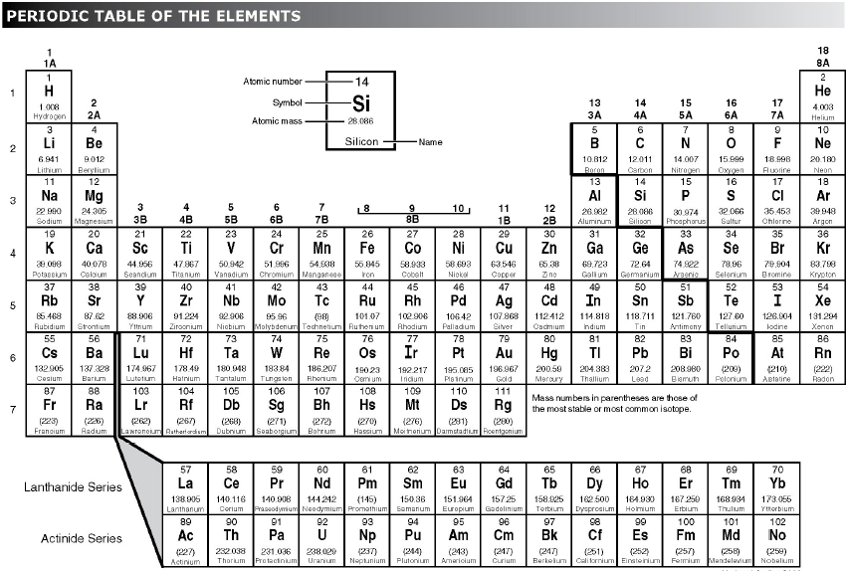
Watch it!
Directions:
1. Go to: https://www.youtube.com/watch?v=hcds5Ob59Dg
2. Answer the questions below.
Questions:
1. What did the scientists find was causing a hissing sound in early telephone technology?
2. What direction was it coming from?
3. The scientists partnered with other scientists from Princeton to determine the original source of the hissing noise came from what event?
4. What is an ordinary electronic device where you could observe this phenomenon?
Research It!
Directions:
1. Use the infographic on the last page of this document to answer the following questions.
Questions:
1. As the first 300,000 years pass what happens to the temperature of the universe? Hint: Read the text on the infographic.
2. Which subatomic particle is the first to show up in the universe? (Subatomic- pieces that make up atoms)
3. When were the first recognizable elements thought to be created?
4. In the future, what is expected to happen to the distances between galaxies based on the Big Bang Theory?
5. What force is responsible for the creation of galaxies and stars?
6. Which were the first present elements in the universe?
7. Why do you think they were the first to show up?
8. As scientists study the far reaches of the universe, which elements do you think are still abundant today?

Write it!
Directions: After you have completed all the previous stations, answer the following questions.
Questions:
- Describe how the galaxies are moving in our universe. Why?
- Describe the chemical composition of most of the mass in the visible universe.
- What are the three pieces of evidence used to support the Big Bang Theory? (Hint: use questions 6 & 7 from the Explore It task for help.)
Assess It!
Directions: After you have completed all other tasks, answer the questions below.
Questions:
1. Which is not a piece of evidence that most scientists use to prove the origin of our universe?
A. Movement of the galaxies (expansion)
B. Cosmic microwave background
C. Presence of hydrogen and helium in the correct percentages throughout the universe
D. The contraction of objects in space

2. Which elements are most abundant in the visible universe?
A. Hydrogen and Carbon B. Carbon and Helium C. Hydrogen and Oxygen D. Hydrogen and Helium

3.Which is not a true statement about the evidence to support the origin of our universe?
A. Galaxies are expanding at a exponential rate in the universe.
B. The universe is continually heating up and gaining energy.
C. Leftover light from the oldest light in the universe is observable.
D. Hydrogen makes up about 73%, and helium makes up about 25% of all the mass in the universe.

4. As galaxies move away from our galaxy a shift on the electromagnetic spectrum (EMS) is noticed. This phenomenon is
called _____________.
A. redshift B. blueshift C. unshift D. blackshift

