Waves Behavior Lab Name: _____________________________________ Date: _________ Period: ____
Objective: Demonstrate and observes the following wave properties: reflection, refraction, and diffraction.
Activity #1 Reflection Click here for video demonstration
- Place the mirror block on the bolded marked line on the bottom of the sheet.
- Do not point the laser at another person!
- Shine the laser along the solid 45° line and toward the “X”. The light from the laser to the mirror is called the incident ray, and the light from the mirror on the dotted line is the reflected ray.
- Angle the laser so its reflected beam lands on the paper within the semi circle. “Trace” the incident laser beam with your finger along the 45° line in toward the mirror. Adjust the position of the laser if necessary.
- Now trace the reflected beam with a finger and note which line the finger moves along. Record your data in the table below.
- Try shining the laser a different angles toward the mirror. Record your findings in the chart below.
Incident Angle | Angle of Reflection
45°

Question: What do you notice about the incident angle when compared to the reflection angle?
____________________________________________________________________________________

Question: What do you think would happen if you placed a second mirror in the path of the reflected laser beam? _________________________________________________________________________________

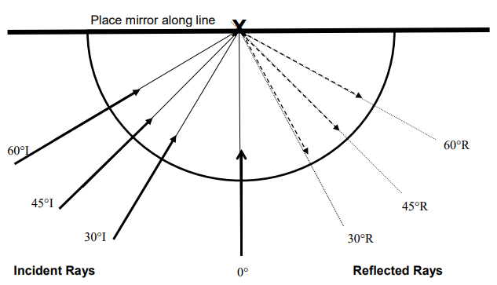

Activity #2 Refraction Click here for video demonstration
- Rotate the container while looking at the straw. What appears to happen to the straw? _________________________

- Unscrew the lid and hold the straw vertically in the center of the container, so that half is in the water and half is out of the water.
- Look at the straw “straight on” at the center point, and then slowly move it to the side of the container (do not move your head with the straw). What do you observe? ___________________________________________

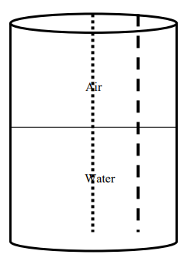
- Hold your lab sheet behind the jar and shine the laser through the water in the container. Note where the red bean is on the paper and place a mark. Repeat the process so that the laser beam shines through air and place a mark.

Activity #3 Diffraction Click here for video demonstration
- Hold the small plastic diffraction grating card by the cardboard edges only. Do not touch the clear film in the cardboard holder.
- Hold the diffraction grating close to (but not touching) your eye, and look at any lights in the room.
- Explain what you observe while looking at lights through the diffraction grating card. ___________________________________________________________________________________________
- Look at the lab station or your desk through the diffraction grating card. Explain what is different when looking at non-light producing objects. _________________________________________________________________
- Pick up the CD and notice the rainbow pattern as you move the CD in different directions. What do you think is causing the rainbow affect? ____________________________________________________________________

Question: Compare the colors of the diffraction grating card to the colors of the CD. Why do you think they are similar? __________________________________________________________________________________________________

Activity #4 The Arrows (If time allows) Click here to watch the demonstration.
- On an index card or the bottom of your paper draw two arrows, one on top of the other, pointing the same direction.
- Hold the card with the arrows behind the round clear container and look through the container to see the arrows.
- With your other hand begin to pour water into the container. Keep your eyes on the arrows.
- As your pour the water the arrows should flip directions.
Question: Which wave behavior caused the arrows to flip directions as the water is pour into the container? Explain how this works. _________________________________________________________________________________________________

