Wave Behavior Venn Diagram
Directions:
First: Place the information/example listed below into the Venn diagram.
Second: For numbers 7-13 write the name of the demonstrated property on the line next to the example.
#1 Requires a medium | #2 Does not require a medium
#3 Light waves | #4 sound waves
#5 Energy is lost after Reflection | #6 Wavelength increases after diffraction
#7 a straw looks bent in water:____________ | #8 light will separate into colors:____________
#9 light bounces off a mirror:_____________ | #10 water waves will bend around a barrier:________
#11 sound will bounce off a cliff as an echo: ___________ | #12 light will shine down a hallway: _______________
#13 sound changes speed in different mediums: _________________ | #14 transfer of energy
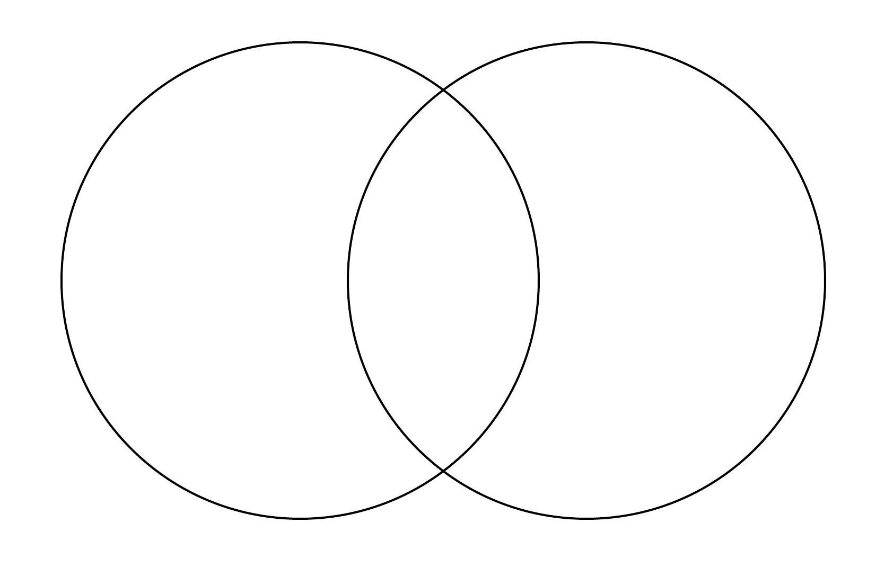
Electromagnetic Waves
Mechanical Waves
Both

