Parent Guide for Week 5 Over Mass Extinction
Day 1 – Monday
Develop a model (e.g. timeline) of the past five mass extinctions.
Phenomenon:
- While watching the video students should write down any questions or observations they have made. Responses will vary depending on each student.
- Endangered or extinct species will vary based off student’s pre-knowledge. Encourage your student to list several species, even if they are not certain they are correct. They can research after they have made their list.
- Pick one species from the list and explain the adaptations the animal/plant has to help it survive in its habitat, and what led to the extinction/endangerment.

- Timeline can be done in any format (paper/pencil, digital, power point, etc.). Students should use the given resource links provided on the student handout. Please encourage your student to refrain from random “googling”. The following information should be included:
- Name of extinction event
- Time Period
- Cause(s) which led to extinction event
- Amount (or percent) of species lost
- Specific species lost (just a few)

Day 2 – Tuesday
- Write a list of possible current factors that may contribute to species extinction and sort the factors into two categories: 1) natural and 2) human influences.
  - Students should use their prior knowledge to create a list of possible factors that occur naturally that could contribute to extinction events. Possible answers could include: an asteroid event, volcanic activity, Weather events, such as an ice age or global warming.
  - Students should use their prior knowledge to create a list of possible factors that occur as a direct result of human activity that could contribute to extinction events. Possible answers could include: Habitat loss from factors such as deforestation, pollution, depletion of natural resources, introduction of invasive non-native species or widespread introduction of infectious diseases.
  - Many possible answers could go here. The goal is to ensure that students understand what makes a factor a natural or one that is influenced by humans.

- Watch “Vanishing species”. Compare natural extinction rates with the elevated extinction rates of today. Over the next 100 years, how many of our species could we lose? “up to 50% of all species on Earth over the next 100 years” should be acquired from the video.
  - Describe five kinds of human activities that result in species extinctions.
  - Students can use this article to help make their list.
Optional day for Observational Task:
Think about factors currently that can contribute to extinction. Which of these factors do you see going on in the area where you live? Answers will vary but possible answers could include: Deforestation, introduction of widespread infectious diseases, pollution, overpopulation, etc. Should be based on where you live and what you see there.
-Make a list of the contributing factors in your area and develop a way to stop or change these things from happening. List needs to include solutions to the problems stated above. Answers could include: Stricter national or global regulations on emissions, number of non-renewable resources used, habitat preservation, More educational awareness of factors and their impact, etc. Should be specific to the problems the student stated above.
-Create a presentation that would educate local citizens of humans being responsible for the sixth extinction and how we can stop this extinction from happening. Students may choose their format to create a presentation can be PowerPoint, poster, prezi, paper, etc. And present to their immediate family. Main goal is to see factors noticed in the world around them, use their research and reasoning and present possible solutions to the problems, and to convince the audience why this is important.
Day 3/4 – Wednesday/Thursday
- Case Study: Select a species that has gone extinct in modern times using the resources below. Create a model (e.g. concept map) to describe the causes and consequences of the extinction. Include the following key data: species names, illustrations or photos, dates of discovery and extinction, biogeographical data (location, initial population size, ecology, and behavior), causes of extinction, and possible actions that may have prevented the extinction.
The IUCN Red List of Threatened Species
One Kind Planet: Top 10 Extinct Animals
20 Extinct Animals We’ve Lost in the Past 150 years

Students are to create a model describing the causes and consequences of the extinction of a species of their choice. This model must include the following key data: species names, illustrations or photos, dates of discovery and extinction, biogeographical data (location, initial population size, ecology, and behavior), causes of extinction, and possible actions that may have prevented the extinction.
Answers may vary. If students decide to utilize the concept map method, there is an example provided. They will need to include the required data with examples for each. They may provide multiple examples for each box of information. The idea of a concept map is to begin with the broad subject and gradually narrow down information.
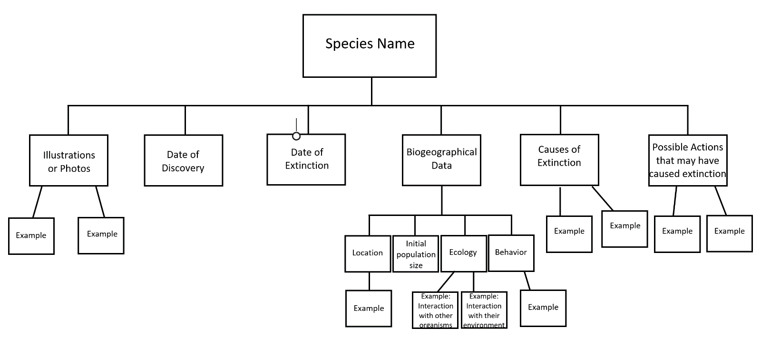
Day 5 – Friday
Claim: Humans will be responsible for the 6th mass extinction event. (Claim is given on the student page.)

Evidence: Students should pull pieces of evidence from the resources researched above that support the claim, such as behaviors that are causing species loss, evidence that is there is species loss happening right now, patterns being repeated from previous extinctions, etc. (Students should be pulling evidence from the resources, but there are many possible pieces of evidence students can choose from.)
- Students wrote out human activities that are causing species extinction on Day 2, this would be a great place to pull evidence from.

Reasoning: Students should add an explanation with each piece of evidence to explain how each piece supports the claim.

An example of a piece of evidence with an explanation:

Poaching has been cited as one of the biggest causes of species loss over the past 150 years. In the example of the North White Rhinoceros, there are only two left in existence as of 2018 and they are both female. Unless researchers can create the next generation in the lab, the entire species will be lost due to humans poaching the rhinoceros for their horns over the past century. Even though restrictions have been placed on poaching to try and preserve the species, humans have also destroyed the habitat of the rhinoceroses which has contributed to the endangerment/extinction of the species.

Pulled from this resource: https://www.popularmechanics.com/science/animals/g201/recently-extinct-animals-list-470209/?slide=1

