Cell Phone Signal Assessment Task

Claim
Students can draw on prior learning about properties and behaviors of waves to develop an explanation of the role of waves in communication systems, using evidence about various types of electromagnetic radiation and the impact of building materials on wave transmission.

DCI: PS4 - Waves and their applications for Information Transfer
- 4.2 Develop and use a model to describe that waves are reflected, absorbed, or transmitted through various materials
TN Standard: 8.PS4.2 - Compare and contrast mechanical waves and electromagnetic waves based on refraction, reflection, transmission, absorption, and their behavior through a vacuum and/or various media.
SEP: Constructing Explanations and Designing Solutions
- Apply scientific ideas, principles, and/or evidence to construct, revise and/or use an explanation for real-world phenomena, examples, or events.
- Construct an explanation that includes qualitative or quantitative relationships between variables that predict(s) and/or describe(s) phenomena
CCC: Systems and System Models
- Systems may interact with other systems; they may have sub-systems and be a part of larger complex systems.

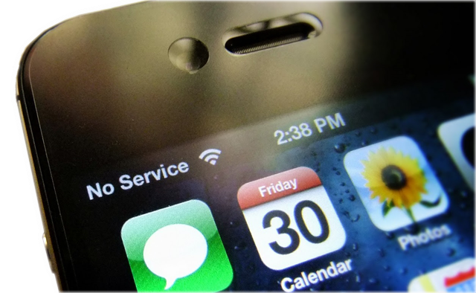
Cell Phone Signal Assessment Task

Day 1 - Monday
Phenomenon

A group of students are working together on a project for school in the downstairs basement area of their local library. Melody is trying to use her cell phone to place a call to order pizza to be delivered. Her cell phone doesn’t have a signal and the call won’t go through.

Stimulus
Melody’s friends make the following claims to help Melody solve her problem:

Mark: “You need to plug the phone into the outlet in the wall so that the signal can go through the wire.”

Luca: “You just need to hold the phone up above your head so that the signal can find your phone.”

Monique: “You need to go outside to an open area so that the signal is stronger.”

Prompt #1
Explain which friend you feel has the best solution to Melody’s problem. Justify your choice with evidence from your understanding of how information travels in communication devices.

Choice:
Justify your Reasoning:

Day 2 - Tuesday
Prompt #2
The chart below provides information about how building material can impact a cell phone signal. Cell phone signal is measured in units called decibel-milliwatts (dBm). In order to connect to make a call, the phone needs to be able to send and/or receive between 50 and 100 dBm. The chart shows the number of dBm that are absorbed or blocked by various building materials, shown in “signal loss”. Based on this information, construct an explanation to describe which material has most likely been used in the building that Melody and the students are working in. Assume (for simplicity’s sake) that the library walls are built of a single material, not a combination.

Building Material | Effect on Cell Phone Signal (dBm)
Concrete | -55.2
Reinforced Concrete | -53.8
Metal | -41.0
Tinted or low-emissivity glass | -32.0
Brick | -15.3
Lumber | -3.27
Traditional glass | -0.07
Drywall | -0

Prompt #3
When Melody’s phone wouldn’t connect to call for pizza, she decided to use the WIFI connection on her laptop computer to order pizza online. Using the diagram of the library below as well as evidence from the data table in prompt #2, explain why Melody was able to connect to the pizza store via the WIFI internet communication system, but not her cellular network system.
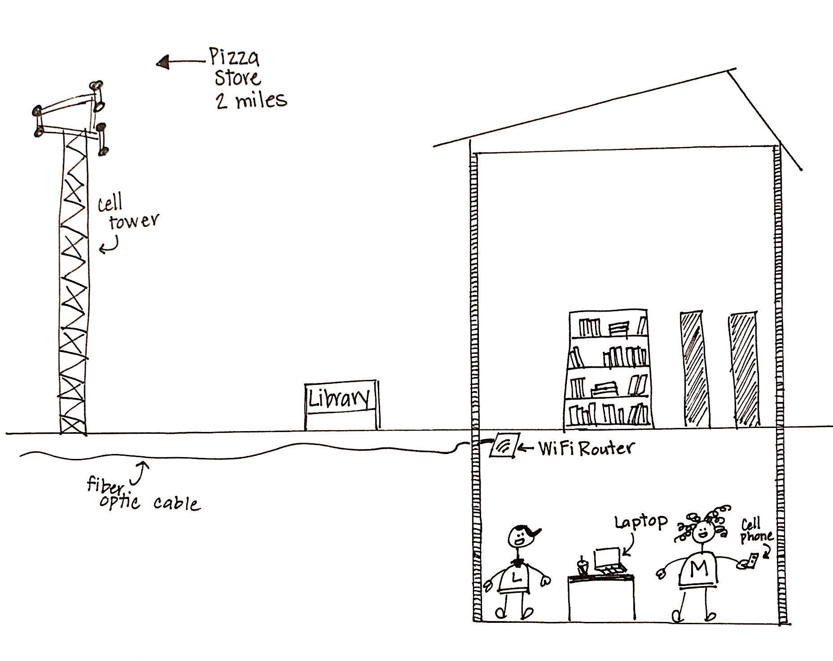

Day 3 - Wednesday
Prompt #4
This WIFI internet communication system has several components: the pizza store’s computer system, the WIFI router at the library, Melody’s computer, and fiber optic cables. Using a model or written explanation, describe how the components of this system transfer information about Melody’s pizza order.

Day 4 – Thursday
Prompt #5
Like other communication systems, Melody’s cell phone transfers information using the energy of the electromagnetic spectrum. This energy can travel very quickly through open space, around and through both natural and man-made objects. The electromagnetic spectrum’s energy transfer can be classified into seven major types, varying from dangerously high-energy Gamma Rays to harmless radio waves. The following table provides information about selected parts of the electromagnetic spectrum:

Type of Energy Transfer | Approximate  Wave Size | Amount of Energy  Transferred | Short-Term Effect on Human DNA
Gamma Rays | atomic nuclei | high energy | harmful
X-Rays | atom | high energy | harmful
Ultraviolet | molecule | medium energy | harmful
Visible light | cell | medium-low energy | not harmful
Infrared | butterfly | medium-low energy | not harmful
Microwave | human being | low energy | not harmful
Radio Waves | building | low energy | not harmful

After learning about the electromagnetic spectrum in science class, Melody makes a claim that, although it isn’t working right now, the information in her cell phone is probably transferred using microwaves or radio waves. Using what you know about the spectrum and the data table above as evidence, support Melody’s claim with evidence and reasoning.

Claim:
Cell phones transfer information using microwaves or radio waves.
Evidence:

Reasoning:

Day 5 – Friday
Complete the observational task below.

Evaluate the different communication systems in your house. What role do waves play in those different communication systems? How are you able to complete an assignment online? How is that different than texting or calling your friend from your cell phone? Develop a model that shows how waves are used in at least one communication system in your house.

Sources
https://eyesaas.com/wifi-signal-loss/

https://www.cancer.org/cancer/cancer-causes/radiation-exposure/radiofrequency-radiation.html

https://docs.google.com/document/d/1e0uhvZNjxC0HkKD8hxjUgIVGdbWmaJsgaQ_yFhyAnRE/edit?usp=sharing

https://www.explainthatstuff.com/analog-and-digital.html

http://www.planetoftunes.com/digital-audio/pros-and-cons-of-analogue-and-digital-audio.html#.XROp7-hKiUk

https://www.wilsonamplifiers.com/blog/how-to-read-cell-phone-signal-strength-the-right-way/

