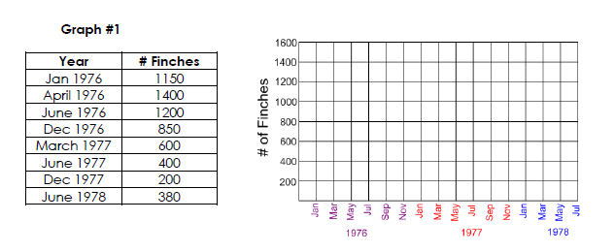
Use Dry Erase Marker to Graph the Finch Population

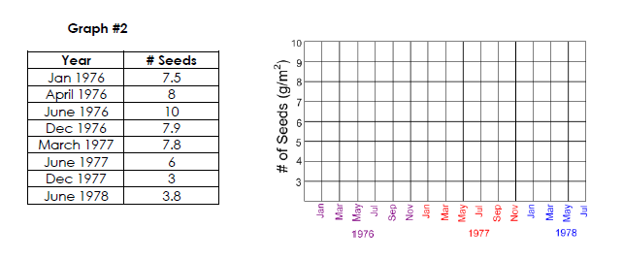
Use Dry Erase Marker to Graph the Number of Seeds

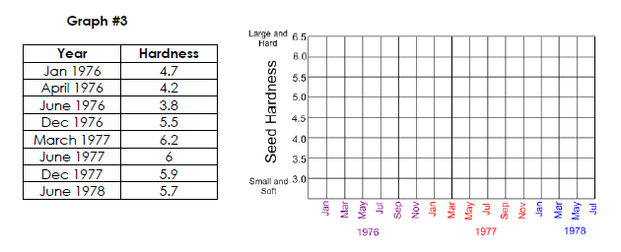

Use Dry Erase Marker to Graph the Seed Hardness

Read the following scenario: In 1834 Charles Darwin studied birds on the Galapagos Islands. He observed that even though all the birds he saw were finches, the various species had different shaped beaks. He proposed that the finches all descended from a common ancestor, and the beak shapes changed as the birds adapted to eat different foods. It was a great theory, but at the time he had no way to prove it. More than 100 years later, Peter and Rosemary Grant from Princeton University set out to prove Darwin’s hypothesis. They studied medium ground finches on Daphne Major, a tiny island in the Galapagos. They were able to measure the beak depth of the 1,200 finches that live on the island. The finches on this volcanic island eat seeds by cracking them open with their beaks. They found that the finch’s beak size was correlated with the size of the seed they ate (large beaked finches ate large seeds, and small beaked finches ate small seeds). Daphne Major typically receives 130mm of rain per year. Then, in 1977 there was a drought and the island only received 24mm of rain. Because of the little rain, there were fewer seeds growing, and 84% of the birds died of starvation.

Work together in your small group to compare data changes over time in the finch population, # of seeds and the hardness of the seeds.
Answer the following on your own paper:
Bird Beaks
- When did the drought on Daphne Major begin?
- What evidence did you use to support your answer in #1?
- What effect did the drought have on the seed size?
- What evidence do you have to support your answer in #3?
- How did the drought change the hardness of the seed?
- What evidence do you have to support your answer in #5?
- Predict which type of birds you think survived the drought in 1977 on the Daphne Major—finches with big beaks or finches with small beaks?
- Describe the patterns you found in the data tables and use those to explain your answer in #7.
- How does a change in habitat change the survival of an organism?

