Wiser.me Gravity Name: _________________________________________ Date: _____________ Period: ______
What is Gravity https://app.wizer.me/preview/FUPUUF
Who is credited with discovering gravity? __________________________________________
The size of the object has an effect on _____________________________________________.
Explain why the planets in our solar system orbit the Sun and not Earth?

What causes high and low tides in the Earth’s oceans? _______________________________
Dr. Bionics says that the paper falls slower than the rock because of gravity. This is false! What other force could cause the paper to fall at a slower rate? (this is not directly stated in the video)

What causes a person to be able to jump higher on the Moon than on Earth?

For gravity, the _________ of the pull depends on the __________ of the objects. Because of ___________ , the ____________ orbit around the sun and the _________ orbits around the earth.
( Word choices: size; planets; mass; moon; gravity)
Mass and Distance
Sketch the pictures and labels below.

Which object would experience the greatest gravitational pull from the Earth and explain why?
Apple Bowling Ball Ping Pong Ball Science Teacher

If you had a bag of taki’s in one hand and a Gatorade in the other hand, how could you increase the gravity between the two objects?
Circle the picture in example A and example C showing the greatest gravitational attraction. Explain why the picture you circled shows more gravitational attraction.
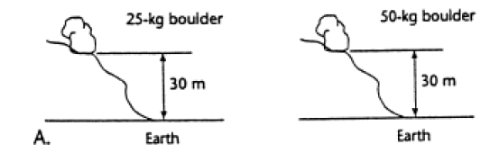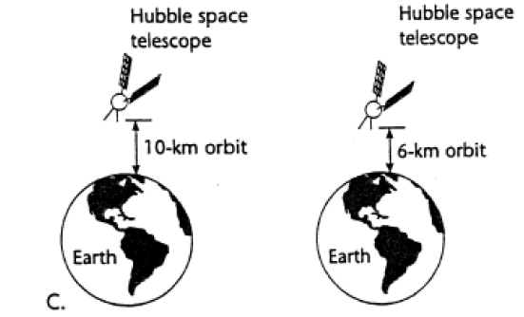
Planets and Motion (Read the article link!! You do not need to watch the video.)
Gravity gets _______ for bigger objects, and ________ the farther away they are from each other.

What two forces keep the planets in their orbits around the sun? ___________ ___________
Gravity wants to pull everything together. What force prevents the Earth from crashing into the Sun? _______________________
Object in Motion |  | The more mass an object has
Object at Rest |  | Stays at motion
An object’s resistance to change |  | Stays at rest
The more inertia an object has |  | Inertia

Formation of our solar system
What force caused all the particles to pull back together after the explosion? ________
What is a solar nebula?

What do you think caused the particles stuck together to form planets and moons?

Orbits
What is the shape that celestial bodies orbit around other celestial bodies? ___________________
How long is one of Earth’s orbits? ____________
Moons and Tides
The Earth’s coastlines experience ______ high tides each day and ______ low tides each day.
Gravity from which celestial body causes high and low tides? ____________________
Explain the position of the Sun, Earth, and Moon during a spring tide.

The moon's ___________ pull generates something called the ___________ . On the side of ___________ that is directly facing the moon, the moon's gravitational pull is the ____________ . The water on that side is pulled strongly in the direction of the ____________. (Word choices: moon; strongest; Earth; tidal force; gravitational)
In the space below sketch a picture of Earth’s tides. Be sure to include the Earth, Moon and Sun.

